**Advanced Face Recognition based Non-Vaccination Population Finder and Alert System**

**Abstract**

Vaccinations are an important and effective cornerstone of preventive medical care with significant health benefits. Vaccination is crucial to limit the pandemic spread of SARS-CoV-2/COVID-19. The government has started vaccination to prevent the continuous spread of corona infection in India. Therefore, besides the development and supply of vaccines, it is essential that sufficient individuals are willing to get vaccinated, but concerning proportions of populations worldwide show vaccine hesitancy. However, it soon became clear that to end the pandemic, we would have to address another ubiquitous problem: the widespread hesitancy toward or downright rejection of vaccination. To achieve population immunity first we have to find the non-vaccinated population to this end, this project proposed an Aadhaar-based facial recognition system is used to find non-vaccination citizen and alert them using Artificial Intelligence. Deep learning in the form of Convolutional Neural Networks (CNNs) to perform the face recognition and seems to be an adequate method to carry out face recognition due to its high accuracy. A CNN is a type of Deep Neural Network (DNN) that is optimized for complex tasks such as image processing, which is required for facial recognition. CNNs consist of multiple layers of connected neurons: there is an input layer, an output layer, and multiple layers between these two. In the context of the coronavirus disease (COVID-19) pandemic, A face recognition-based person’s current vaccination status to protect against COVID-19 can then be used for continuity of care or as proof of vaccination for purposes other than health care. Facial recognition technology (FRT) along with the Aadhaar to authenticate people before entering into any kinds of service. This project provides COVID-19 vaccination status using their face and attest that an individual has received a vaccine or not and alert them to get vaccinated.

**CHAPTER 2**

**INTRODUCTION**

**1.1. Overview**

A vaccine can confer active immunity against a specific harmful agent by stimulating the immune system to attack the agent. Once stimulated by a vaccine, the antibody-producing cells, called B cells (or B lymphocytes), remain sensitized and ready to respond to the agent should it ever gain entry to the body. A vaccine may also confer passive immunity by providing antibodies or lymphocytes already made by an animal or human donor. Vaccines are usually administered by injection (parenteral administration), but some are given orally or even nasally (in the case of flu vaccine). Vaccines applied to mucosal surfaces, such as those lining the gut or nasal passages, seem to stimulate a greater antibody response and may be the most effective route of administration. (For further information, see immunization.).

**The first vaccines**

The first vaccine was introduced by British physician Edward Jenner, who in 1796 used the cowpox virus (vaccinia) to confer protection against smallpox, a related virus, in humans. Prior to that use, however, the principle of vaccination was applied by Asian physicians who gave children dried crusts from the lesions of people suffering from smallpox to protect against the disease. While some developed immunity, others developed the disease. Jenner’s contribution was to use a substance similar to, but safer than, smallpox to confer immunity. He thus exploited the relatively rare situation in which immunity to one virus confers protection against another viral disease. In 1881 French microbiologist Louis Pasteur demonstrated immunization against anthrax by injecting sheep with a preparation containing attenuated forms of the bacillus that causes the disease. Four years later he developed a protective suspension against rabies.

**Vaccine effectiveness**

After Pasteur’s time, a widespread and intensive search for new vaccines was conducted, and vaccines against both bacteria and viruses were produced, as well as vaccines against venoms and other toxins. Through vaccination, smallpox was eradicated worldwide by 1980, and polio cases declined by 99 percent. Other examples of diseases for which vaccines have been developed include mumps, measles, typhoid fever, cholera, plague, tuberculosis, tularemia, pneumococcal infection, tetanus, influenza, yellow fever, hepatitis A, hepatitis B, some types of encephalitis, and typhus—although some of those vaccines are less than 100 percent effective or are used only in populations at high risk. Vaccines against viruses provide especially important immune protection, since, unlike bacterial infections, viral infections do not respond to antibiotics.

**Vaccine types**

The challenge in vaccine development consists in devising a vaccine strong enough to ward off infection without making the individual seriously ill. To that end, researchers have devised different types of vaccines. Weakened, or attenuated, vaccines consist of microorganisms that have lost the ability to cause serious illness but retain the ability to stimulate immunity. They may produce a mild or subclinical form of the disease. Attenuated vaccines include those for measles, mumps, polio (the Sabin vaccine), rubella, and tuberculosis. Inactivated vaccines are those that contain organisms that have been killed or inactivated with heat or chemicals. Inactivated vaccines elicit an immune response, but the response often is less complete than with attenuated vaccines. Because inactivated vaccines are not as effective at fighting infection as those made from attenuated microorganisms, greater quantities of inactivated vaccines are administered. Vaccines against rabies, polio (the Salk vaccine), some forms of influenza, and cholera are made from inactivated microorganisms. Another type of vaccine is a subunit vaccine, which is made from proteins found on the surface of infectious agents. Vaccines for influenza and hepatitis B are of that type. When toxins, the metabolic by-products of infectious organisms, are inactivated to form toxoids, they can be used to stimulate immunity against tetanus, diphtheria, and whooping cough (pertussis).

In the late 20th century, advances in laboratory techniques allowed approaches to vaccine development to be refined. Medical researchers could identify the genes of a pathogen (disease-causing microorganism) that encode the protein or proteins that stimulate the immune response to that organism. That allowed the immunity-stimulating proteins (called antigens) to be mass-produced and used in vaccines. It also made it possible to alter pathogens genetically and produce weakened strains of viruses. In that way, harmful proteins from pathogens can be deleted or modified, thus providing a safer and more-effective method by which to manufacture attenuated vaccines.

Recombinant DNA technology has also proven useful in developing vaccines to viruses that cannot be grown successfully or that are inherently dangerous. Genetic material that codes for a desired antigen is inserted into the attenuated form of a large virus, such as the vaccinia virus, which carries the foreign genes “piggyback.” The altered virus is injected into an individual to stimulate antibody production to the foreign proteins and thus confer immunity. The approach potentially enables the vaccinia virus to function as a live vaccine against several diseases, once it has received genes derived from the relevant disease-causing microorganisms. A similar procedure can be followed using a modified bacterium, such as Salmonella typhimurium, as the carrier of a foreign gene.Vaccines against human papillomavirus (HPV) are made from virus like particles (VLPs), which are prepared via recombinant technology. The vaccines do not contain live HPV biological or genetic material and therefore are incapable of causing infection. Two types of HPV vaccines have been developed, including a bivalent HPV vaccine, made using VLPs of HPV types 16 and 18, and a tetravalent vaccine, made with VLPs of HPV types 6, 11, 16, and 18. Another approach, called naked DNA therapy, involves injecting DNA that encodes a foreign protein into muscle cells. The cells produce the foreign antigen, which stimulates an immune response.Vaccines based on RNA have been of particular interest as a means of preventing diseases such as influenza, cytomegalovirus infection, and rabies. Messenger RNA (mRNA) vaccines are advantageous because the way in which they are made allows them to be developed more quickly than vaccines made via other methods. In addition, their production can be standardized, enabling rapid scale-up for the manufacture of large quantities of vaccine. Novel mRNA vaccines are safe and effective; they do not contain live virus, nor does the RNA interact with human DNA.

**Table of vaccine-preventable diseases**

Vaccine-preventable diseases in the India, presented by year of vaccine development or licensure.

| **Disease** | **Year** |
| --- | --- |
| *Vaccine recommended for universal use in U.S. children. For smallpox, routine vaccination was ended in 1971. | |
| **Vaccine developed (i.e., first published results of vaccine usage). | |
| ***Vaccine licensed for use in United States. | |
| smallpox* | 1798** |
| rabies | 1885** |
| typhoid | 1896** |
| cholera | 1896** |
| plague | 1897** |
| diphtheria* | 1923** |
| pertussis* | 1926** |
| tetanus* | 1927** |
| tuberculosis | 1927** |
| influenza | 1945*** |
| yellow fever | 1953*** |
| poliomyelitis* | 1955*** |
| measles* | 1963*** |
| mumps* | 1967*** |
| rubella* | 1969*** |
| anthrax | 1970*** |
| meningitis | 1975*** |
| pneumonia | 1977*** |
| adenovirus | 1980*** |
| hepatitis B* | 1981*** |
| Haemophilus influenzae type b* | 1985*** |
| Japanese encephalitis | 1992*** |
| hepatitis A | 1995*** |
| [varicella](https://www.britannica.com/science/chickenpox)* | 1995*** |
| [Lyme disease](https://www.britannica.com/science/Lyme-disease) | 1998*** |
| rotavirus* | 1998*** |
| human papillomavirus | 2006 |
| [dengue fever](https://www.britannica.com/science/dengue) | 2019 |

**1.1.1. Covid 19**

At the end of 2019, a novel coronavirus now known as severe acute respiratory syndrome coronavirus 2 (SARS-CoV-2) was identified as the cause of a cluster of pneumonia cases in Wuhan, a city in the Hubei Province of China. It rapidly spread, resulting in a global pandemic. In February 2020, the World Health Organization named the disease COVID-19, which stands for coronavirus disease 2019. The world is in the midst of a COVID-19 pandemic. As WHO and partners work together on the response -- tracking the pandemic, advising on critical interventions, distributing vital medical supplies to those in need--- they are racing to develop and deploy safe and effective vaccines.

Vaccines save millions of lives each year. Vaccines work by training and preparing the body’s natural defenses – the immune system – to recognize and fight off the viruses and bacteria they target. After vaccination, if the body is later exposed to those disease-causing germs, the body is immediately ready to destroy them, preventing illness.

There are several safe and effective vaccines that prevent people from getting seriously ill or dying from COVID-19. This is one part of managing COVID-19, in addition to the main preventive measures of staying at least 1 metre away from others, covering a cough or sneeze in your elbow, frequently cleaning your hands, wearing a mask and avoiding poorly ventilated rooms or opening a window.

As of 15 November 2021, WHO has evaluated that the following vaccines against COVID-19 have met the necessary criteria for safety and efficacy:

* AstraZeneca/Oxford vaccine
* Johnson and Johnson
* Moderna
* Pfizer/BionTech
* Sinopharm
* Sinovac
* COVAXIN

**1.2. Covid19 Vaccination in India**

COVID-19 vaccines in India and elsewhere are mostly two shot vaccines. High efficiency requires both doses of COVID-19 vaccines to be administered that can provide protection against fatal infection. As the second wave of COVID-19 infection picked up, India saw a high rate of COVID infection and deaths among the elderly people and people with comorbidities. Elderly and the people with comorbidities were the ones who were at high risk of COVID-19 infection, and hence they were prioritized to receive COVID-19 vaccine shots relative to others in the phase wise vaccine rollout. Many among them who were vaccinated with the first dose contracted COVID-19 infection and some of them died as the first dose alone was not meant to build sufficient immunity to fight severe COVID infection. However, the myth developed particularly in the rural areas that covid vaccines were causing deaths and illness. This too likely contributed to vaccine hesitancy during the third and the fourth phase of the vaccination drive.

**1.3. Problem Identified**

From the beginning of this COVID-19 pandemic, it has been witnessed that very less attention has been paid on risk communication, leading to social isolation and discrimination of COVID patients, community resistance toward testing, etc., It is of utmost importance to carry out intensive risk communication and advisory activities to make people aware who actually require it and how much protection it can give. In due course of time, the demand of vaccine might keep on decreasing. Further, acceptability of vaccine for the general population is also questionable. History revealed poor utilization of flu vaccine introduced after H1N1 pandemic. Hence, a pre-introduction acceptability survey among the general population is recommended. Although vaccination against COVID19 is voluntary, generating a certificate after vaccination may point to a purported design to force people to adopt vaccines as it may be mandated for travel and other businesses. Underutilized vaccines may create an economic burden for the society. COVID-19 digital certificate to show proof of only COVID-19 vaccinations in India.

However, in the context of vaccination certificates, it is necessary to examine the risks that have been repeatedly highlighted by the Indian and global communities, namely the growing market for counterfeit certificates of various kinds. Europol, for example, has also warned in its reports of the risks of misuse – in particular of test certificates. False certificates can pose a significant risk to public health. The authorities of one Member State must be sure that the information contained in a certificate issued in another Member State is reliable, that it has not been falsified, that it belongs to the person presenting it and that anyone verifying the information has access to only the minimum amount of information necessary. To achieve population immunity first we have to find the non-vaccinated population to this end, this project proposed an Aadhaar-based facial recognition system is used to find non-vaccination citizen and alert them using Artificial Intelligence.

**1.4. Artificial Intelligence**

Artificial Intelligence (AI) is the field of computer science dedicated to solving cognitive problems commonly associated with human intelligence, such as learning, problem solving, and pattern recognition. Artificial Intelligence, often abbreviated as "AI", may connote robotics or futuristic scenes, AI goes well beyond the automatons of science fiction, into the non-fiction of modern-day advanced computer science. Professor Pedro Domingos, a prominent researcher in this field, describes “five tribes” of machine learning, comprised of symbolists, with origins in logic and philosophy; connectionists, stemming from neuroscience; evolutionaries, relating to evolutionary biology; Bayesians, engaged with statistics and probability; and analogizes with origins in psychology. Recently, advances in the efficiency of statistical computation have led to Bayesians being successful at furthering the field in a number of areas, under the name “machine learning”. Similarly, advances in network computation have led to connectionists furthering a subfield under the name “deep learning”. Machine learning (ML) and deep learning (DL) are both computer science fields derived from the discipline of Artificial Intelligence.

Broadly, these techniques are separated into “supervised” and “unsupervised” learning techniques, where “supervised” uses training data that includes the desired output, and “unsupervised” uses training data without the desired output.

AI becomes “smarter” and learns faster with more data, and every day, businesses are generating this fuel for running machine learning and deep learning solutions, whether collected and extracted from a data warehouse like Amazon Redshift, ground-truthed through the power of “the crowd” with Mechanical Turk, or dynamically mined through Kinesis Streams. Further, with the advent of IoT, sensor technology exponentially adds to the amount of data to be analyzed -- data from sources and places and objects and events that have previously been nearly untouched.

**1.4.1. History of AI**

The history of artificial intelligence goes as far back as ancient Greece. However, it’s the rise of electronic computing that made AI a real possibility. Note that what is considered AI has changed as the technology evolves. For example, a few decades ago, machines that could perform optimal character recognition (OCR) or simple arithmetic were categorized as AI. Today, OCR and basic calculations are not considered AI but rather an elementary function of a computer system.

* 1950s – Alan Turing, a man famous for breaking the WWII ENIGMA code used by the Nazis, publishes the Computing Machinery and Intelligence paper in the Mind. He attempts to answer the question of whether machines can think. He outlines the Turing Test that determines whether a computer shows the same intelligence as a human. The test holds that an AI system should have the ability to hold a conversation with a human without the human knowing they are speaking to an AI system. The first ever AI conference is held at Dartmouth College. It’s here that the term artificial intelligence was first used.
* 1960s – The US Department of Defense through DARPA takes great interest in AI and embarks on developing computer programs that mimic human reasoning. Frank Rosenblatt builds the Mark 1 Perceptron computer based on a neural network that learns through experience.
* 1970s – DARPA completes various street mapping projects.
* 1980s – A more complex wave of AI emerges. Neural networks with backpropagation algorithms find widespread application in AI systems.
* 1990s – Exponentially growing volumes of data are produced. Powerful computers process large quantities of data quickly. The Deep Blue supercomputer defeats world chess champion Garry Kasparov twice. The Genome Sequencing project and other similarly complex undertakings generate vast information. Computing advances make it possible for this data to be stored, accessed, and analyzed.
* 2000s – The Internet Revolution drives AI to unprecedented heights. Big data joins corporate lexicon. DARPA rolls out intelligent personal assistants long before Alexa, Siri, Cortana, and Google Assistant become household names. This paves the way for the reasoning and automation that’s a part of present-day personal computers and smartphones. That includes smart search systems and decision support systems that augment and complement human abilities.
* 2010s – China’s search giant Baidu unveils the Minwa supercomputer that relies on a convolutional neural network to identify, analyze, and categorize images with higher accuracy than the average human. The AlphaGo deep neural network program from DeepMind beats Go world champion Lee Sodol in a five-game match. Go is an ancient Chinese game that’s considerably more complex than chess.

**1.4.2. AI in everyday life**

Below are some AI applications that you may not realize are AI-powered:

**Online shopping and advertising**

Artificial intelligence is widely used to provide personalized recommendations to people, based for example on their previous searches and purchases or other online behavior. AI is hugely important in commerce: optimizing products, planning inventory, logistics etc.

**Web search**

Search engines learn from the vast input of data, provided by their users to provide relevant search results.

**Digital personal assistants**

Smartphones use AI to provide services that are as relevant and personalized as possible. Virtual assistants answering questions, providing recommendations and helping organize daily routines have become ubiquitous.

**Machine translations**

Language translation software, either based on written or spoken text, relies on artificial intelligence to provide and improve translations. This also applies to functions such as automated subtitling.

**Smart homes, cities and infrastructure**

Smart thermostats learn from our behavior to save energy, while developers of smart cities hope to regulate traffic to improve connectivity and reduce traffic jams.

**Cars**

While self-driving vehicles are not yet standard, cars already use AI-powered safety functions. The EU has for example helped to fund VI-DAS, automated sensors that detect possible dangerous situations and accidents.

Navigation is largely AI-powered.

**Cybersecurity**

AI systems can help recognize and fight cyberattacks and other cyber threats based on the continuous input of data, recognizing patterns and backtracking the attacks.

**Artificial intelligence against Covid-19**

In the case of Covid-19, AI has been used in thermal imaging in airports and elsewhere. In medicine it can help recognize infection from computerized tomography lung scans. It has also been used to provide data to track the spread of the disease.

**Fighting disinformation**

Certain AI applications can detect fake news and disinformation by mining social media information, looking for words that are sensational or alarming and identifying which online sources are deemed authoritative.

**1.4.3. Deep Learning**

Deep Learning is a branch of machine learning that involves layering algorithms in an effort to gain greater understanding of the data. The algorithms are no longer limited to create an explainable set of relationships as would a more basic regression. Instead, deep learning relies on these layers of non-linear algorithms to create distributed representations that interact based on a series of factors. Given large sets of training data, deep learning algorithms begin to be able to identify the relationships between elements. These relationships may be between shapes, colors, words, and more. From this, the system can then be used to create predictions. Within machine learning and artificial intelligence, the power of deep learning stems from the system being able to identify more relationships than humans could practically code in software, or relationships that humans may not even be able to perceive. After sufficient training, this allows the network of algorithms to begin to make predictions or interpretations of very complex data.

**Image and Video Classification, Segmentation**

Convolutional Neural Networks out-perform humans on many vision tasks including object classification. Given millions of labeled pictures, the system of algorithms is able to begin identifying the subject of the image. Many photo-storage services include facial recognition, driven by Deep Learning.

**1.5. Project Scope**

India is looking at adding Aadhaar-based facial recognition in an effort to make its COVID-19 vaccination procedure contactless. To test the efficacy of the facial recognition system, which is based on data obtained from the Aadhaar database. Aadhaar is already the “preferred” mode of identity verification and for vaccination certificates. Using facial recognition at vaccine centers risks further marginalizing vulnerable people who may be misidentified and refused the vaccine, and raises fears the controversial technology could become the norm at all centers.

**1.6. Objective of the project**

The main objective of the project is to develop an “Aadhaar-based facial recognition system could soon replace biometric fingerprint or iris scan machines at COVID-19 vaccination finder across the country in order to avoid non-vaccination,”

**CHAPTER 3**

**LITERATURE SURVEY**

1. **A Hybrid Algorithm for Face Detection to Avoid Racial Inequity Due to Dark Skin**

**Authors:** Muhammad, [Syed Sarmad Abbas](https://ieeexplore.ieee.org/author/37089016696), [Adnan Abid](https://ieeexplore.ieee.org/author/37085999025), [Saim Rasheed](https://ieeexplore.ieee.org/author/37086003232)

**Year:**2021

**Link:** <https://ieeexplore.ieee.org/document/9585604>

**Objective:**

The aim of this project is to face detection systems for people with dark skin using a hybrid algorithm based on Gaussian and Explicit rule model.

**Methodology:**

There has been significant development in the facial recognition technology during past few decades. This technology has been widely used by different organizations and governments for defense, security, and surveillance projects. Furthermore, it has now been incorporated into our daily usages, such as consumer applications, personal data protection, or cyber-security, particularly while using smartphones. Most of these systems work very efficient, however, there are some challenges related to the accuracy of results of facial recognition systems when tested on images of people with dark skin. This article highlights the variation in accuracy of existing facial recognition algorithms when applied to dark-skinned people. Furthermore, as a principal contribution it presents a hybrid algorithm based on Gaussian and Explicit rule model that improves the accuracy for face-detection for dark skinned people. The results showed that Gaussian and Explicit Rule hybrid algorithm optimally improved the face detection rate for people with dark skin.

**Merits:**

* Its accuracy is high.
* It is efficient and time consuming is low.

**Demerits:**

* The accuracy is very low to detect people with dark skin.
* To detect the variation among the skin tone within races has been considered as major challenge for all skin modeling techniques.

1. **An End-To-End Emotion Recognition Framework Based on Temporal Aggregation of Multimodal Information**

**Author:** [Anamaria Ra](https://ieeexplore.ieee.org/author/37085393133), [Andreea Birhala](https://ieeexplore.ieee.org/author/37088465019), [Nicolae-Catalin Ristea](https://ieeexplore.ieee.org/author/37087095545), [Liviu-Cristian Dutu](https://ieeexplore.ieee.org/author/37075565200)

**Year:**2021

**Link:** <https://ieeexplore.ieee.org/document/9552845>

**Objective:**

The aim of this project is to present a robust end-to-end architecture that incorporates multimodal information for emotion recognition using end-to-end neural network architecture, called TA-AVN.

**Methodology:**

Humans express and perceive emotions in a multimodal manner. The multimodal information is intrinsically fused by the human sensory system in a complex manner. The feature descriptors for audio and video representations are extracted using simple Convolutional Neural Networks (CNNs), leading to real-time processing. Undoubtedly, collecting annotated training data remains an important challenge when training emotion recognition systems, both in terms of effort and expertise required. The proposed approach of end-to-end neural network architecture, called TA-AVN solves this problem by providing a natural augmentation technique that allows achieving a high accuracy rate even when the amount of annotated training data is limited. This article proposes a novel audio-visual multimodal fusion framework for emotion recognition based on a random selection of analysis windows collected from individual temporal segments of the input video and the proposed method can be easily adapted to work also when the amount of available annotated data is limited.

**Merits:**

* It is efficient to use
* It is flexible in combining audio and video data with different sampling rates across modalities.
* Computational complexity of the proposed solution is not very high.

**Demerits:**

* Collecting annotated training data remains an important challenge when training emotion recognition systems.
* Its accuracy is low and not efficient.
* Time consuming job.

1. **Exposing Fake Faces Through Deep Neural Networks Combining Content and Trace Feature Extractors**

**Authors:** [Eunji Kim](https://ieeexplore.ieee.org/author/37088963189), [Sungzoon Cho](https://ieeexplore.ieee.org/author/37441817500)

**Year:**2021

**Link:** <https://ieeexplore.ieee.org/document/9531572>

**Objective:**

The aim of this project is to expose fake face media forensics using a hybrid face forensics framework based on a convolutional neural network (CNN).

**Methodology:**

With the breakthrough of computer vision and deep learning, there has been a surge of realistic looking fake face media manipulated by AI such as DeepFake or Face2Face that manipulate facial identities or expressions. The fake faces were mostly created for fun, but abuse has caused social unrest. For example, some celebrities have become victims of fake pornography made by DeepFake. There are also growing concerns about fake political speech videos created by Face2Face. To maintain individual privacy as well as social, political, and international security, it is imperative to develop models that detect fake faces in media. This article proposes a hybrid face forensics framework based on a convolutional neural network combining the two forensics approaches to enhance the manipulation detection performance. To validate the proposed framework is used a public Face2Face dataset and a custom DeepFake dataset collected on our own. The proposed model is a type of convolutional neural networks containing two types of feature extractors to simultaneously extract content features and trace features from a face image. The former feature extractor is trained by transferring and fine-tuning the feature extractor of a pre-trained object recognition model. Thus, the extracted features are specialized to represent various contents in a face. The latter feature extractor is based on the local relationship between neighboring pixels, by first applying the multi-channel constrained convolution.

**Merits:**

* Highest accuracy at various video compression levels when compared to the baseline models, confirming its robustness.
* It effectively learns the different characteristics of fake manipulation methods.

**Demerits:**

* It is less effective.
* Accuracy is low.

1. **Face Recognition Attendance System Based on Real-Time Video Processing**

**Authors:** [Hao Yang](https://ieeexplore.ieee.org/author/37088498049), [Xiaofeng Han](https://ieeexplore.ieee.org/author/37088495983)

**Year:**2020

**Link:** <https://ieeexplore.ieee.org/document/9138372>

**Objective:**

The aim of this project is to improve the accuracy rate, stability, and truancy rate of the face recognition system using linear discriminant analysis (LDA) algorithm.

**Methodology:**

College attendance management for students has become one of the hot issues in the society, so the management of college students should be strengthened. However, most college students still use traditional manual attendance for daily attendance, using paper signatures or teacher orders, but now with the gradual rise of technology, some new methods point out that gradually, a few colleges and universities will use punch card fingerprints and smart attendance methods. Although there are some ways to stimulate attendance, the effect is not so effective. This article proposes a linear discriminant analysis (LDA) algorithm to overcome the above issues. This algorithm is to find a set of linear transformations that minimize the intra-class dispersion between each category and maximize the inter-class dispersion.

**Merits:**

* The face recognition time attendance system and manual fingerprint punching are more stable and correctly identify check-ins.
* Rate of skipping classes is significantly reduced compared with the control group, only about 13%.
* The efficiency is greatly improved, which can prevent students from leaving early and skipping classes.

**Demerits:**

* It is difficult to analyze the interface settings of the face recognition attendance system using real-time video processing.
* The accuracy rate of the face recognition system is very low.
* The stability of the face recognition attendance system with real-time video processing is low.

1. **Learning Domain-Invariant Discriminative Features for Heterogeneous Face Recognition**

**Authors:** [Shanmin Yang](https://ieeexplore.ieee.org/author/37088567957), [Keren Fu](https://ieeexplore.ieee.org/author/37087244855), [Xiao Yang](https://ieeexplore.ieee.org/author/37088567680), [Ye Lin](https://ieeexplore.ieee.org/author/37088441428), [Jianwei Zhang](https://ieeexplore.ieee.org/author/37088567622), [Cheng Peng](https://ieeexplore.ieee.org/author/37088567717)

**Year:**2020

**Link:** https://ieeexplore.ieee.org/document/9262951

**Objective:**

The aim is this project is to develop a novel framework for heterogeneous face recognition (HFR), integrating domain-level and class-level alignment in one unified network using domain-invariant discriminative features (DIDF) method.

**Methodology:**

Heterogeneous face recognition (HFR), referring to matching face images across different domains, is a challenging problem due to the vast cross-domain discrepancy and insufficient pairwise cross-domain training data. This article proposes a quadruplet framework for learning domain-invariant discriminative features (DIDF) for HFR, which integrates domain-level and class-level alignment in one unified network. The domain-level alignment reduces the cross-domain distribution discrepancy. The class-level alignment based on a special quadruplet loss is developed to further diminish the intra-class variations and enlarge the inter-class separability among instances, thus handling the misalignment and adversarial equilibrium problems confronted by the domain-level alignment. Extensive experiments are conducted on four challenging benchmarks, quantitative comparisons against some state-of-the-art HFR methods demonstrate the effectiveness and superiority of the proposed DIDF method in heterogeneous face recognition.

**Merits:**

* The effectiveness and superiority of the proposed DIDF framework in learning domain-invariant discriminative features for HFR is high.
* Besides, DIDF is a general framework in which inner modules can be replaced/improved for other problems such as pose/lighting/expression-invariant face recognition.

**Demerits:**

* Matching face images across different domains, is a challenging problem.
* Lacking in sufficient pairwise cross-modality training data.
* Accuracy is low.

**6. Face Detection Based on Receptive Field Enhanced Multi-Task Cascaded Convolutional Neural Networks**

**Authors:** [Xiaochao Li](https://ieeexplore.ieee.org/author/37539519300), [Zhenjie Yang](https://ieeexplore.ieee.org/author/37088518683), [Hongwei Wu](https://ieeexplore.ieee.org/author/37088515450)

**Year:**2020

**Link:** https://ieeexplore.ieee.org/document/9195457

**Objective:**

The aim of this project is to enhance the feature discriminability and robustness for small targets using new face detection model Receptive Field Enhanced Multi-Task Cascaded CNN (RFEMTCNN).

**Methodology:**

With the continuous development of deep learning, face detection methods have made the greatest progress. For real-time detection, cascade CNN based on the lightweight model is still the dominant structure that predicts face in a coarse-to-fine manner with strong generalization ability. Compared to other methods, it is not required for a fixed size of the input. However, MTCNN still has poor performance in detecting tiny targets. This article proposes a new face detection model RFEMTCNN which takes advantage of the Inception-V2 block and receptive field block to enhance the feature discriminability and robustness for small targets. This author uses the Global Average Pooling (GAP) to replace the second to last fully connected layers in order to enforce correspondences between feature maps and categories, avoid overfitting, and reduce the network parameters. The AM-Softmax loss function is introduced to enhance the discriminability of the R-Net.

**Merits:**

* The accuracy of face detection is high.
* It improves model generalization ability.
* Time consumption is low.

**Demerits:**

* For real-time detection, cascade CNN based on the lightweight model is still the dominant structure
* It is not required for a fixed size of the input.
* The speed of face detection is low.

**7. You Only Move Once: An Efficient Convolutional Neural Network for Face Detection**

**Authors:** [Jie Xu](https://ieeexplore.ieee.org/author/37086526577), [Ye Tian](https://ieeexplore.ieee.org/author/37086525425), [Haoyu Wu](https://ieeexplore.ieee.org/author/37087115767), [Baowen Luo](https://ieeexplore.ieee.org/author/37087115673), [Jinhong Guo](https://ieeexplore.ieee.org/author/37085456861)

**Year:**2019

**Link:** <https://ieeexplore.ieee.org/document/8908787>

**Objective:**

The aim of this project is to enables different detection module adequately trained by different scales of samples using You Only Move Once (YOMO)detector.

**Methodology:**

Face detection is generally a key component of the human centered ‘‘smart city’’, relating to facial expression analysis, identification, individual service, etc. Despite being widely researched, it remains a difficult problem to build real-time face detectors with high accuracy under natural conditions. This article proposes a real-time face detector named You Only Move Once (YOMO), which consists of depth wise separable convolutions and contains multiple feature fusion structures in the form of top-bottom. Each detection module is only responsible for detecting faces within the corresponding scale. A random cropping strategy that is more consistent with multi-scale detection structures allows each detection module to be trained by a sufficient number of samples. The proposed ellipse regressor can greatly improve the detection recall rate under the continuous measures of FDDB. YOMO has only 21 million parameters and achieves superior performance with 51 FPS for a 544 × 544 input image on a GPU.

**Merits:**

* Less computation.
* Good support for the security problem of exploitation identification and facial spoofing detection in aspect of accuracy and latency.
* Furthermore, this method uses rectangular and ellipse bounding boxes, and it can provide better support for complex environments in actual application.

**Demerits:**

* Small faces cannot be handled.
* The multi-scale inference helps detect variable faces is low.
* Large computational overhead due to complex network structures cause the disabling of real-time detection.

**8. Face Detection Method Based on Cascaded Convolutional Networks**

**Authors:** [Rong Qi](https://ieeexplore.ieee.org/author/37086841556), [Rui-Sheng Jia](https://ieeexplore.ieee.org/author/37086840084), [Qi-Chao Mao](https://ieeexplore.ieee.org/author/37086842749), [Hong-Mei Sun](https://ieeexplore.ieee.org/author/37085964216), [Ling-Qun Zuo](https://ieeexplore.ieee.org/author/37086840335)

**Year:**2019

**Link:** <https://ieeexplore.ieee.org/document/8794507>

**Objective:**

The aim of this project is to detect the problems of weak generalization ability of single structure and large network parameters using cascade convolutional neural network.

**Methodology:**

Deep learning achieves substantial improvements in face detection. However, the existing methods need to input fixed-size images for image processing and most methods use a single network for feature extraction, which makes the model generalization ability weak. In response to the above problems, our framework leverages a cascaded architecture with three stages of deep convolutional networks to improve detection performance. This article proposed the convolutional neural network is a face detection network based on regression theory. The network replaces the standard convolution in MTCNN with the separable residual module and deletes the task of facial landmarks position. Therefore, only two tasks of face classification and bounding box regression are carried out in the detection stage. The detection accuracy of the network is improved by using the cascading convolutional neural network and the method of expanding the channel in the separable residual module. The depth wise separable convolution is used to reduce the amount of network computation to maintain a fast detection speed.

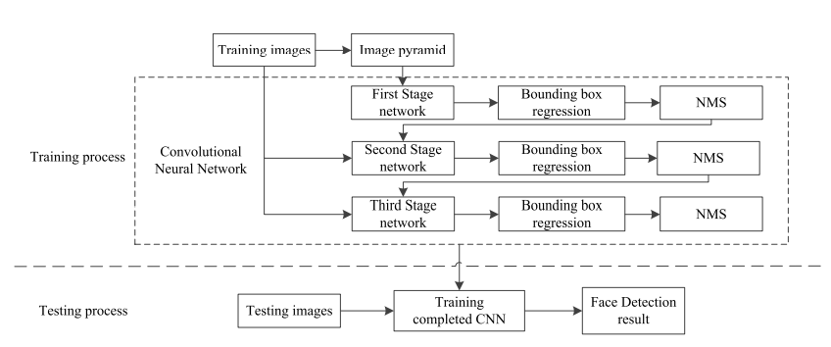

**Merits:**

* It reduces the time required for training and improves the network detection effect.
* The network uses a cascade structure to generate face candidate windows, multi-layer network screening can effectively improve the accuracy of candidate window positioning.
* It improves the accuracy of face detection and ensure real-time performance is high.

**Demerits:**

* Input fixed-size images for image processing in previous methods.
* Most methods use a single network for feature extraction, which makes the model generalization ability weak.

**9. SLR: Semi-Coupled Locality Constrained Representation for Very Low-Resolution Face Recognition and Super Resolution**

**Authors:** [Tao Lu](https://ieeexplore.ieee.org/author/37403550300), [Xitong Chen](https://ieeexplore.ieee.org/author/37086488725), [Yanduo Zhang](https://ieeexplore.ieee.org/author/37405800800), [Chen Chen](https://ieeexplore.ieee.org/author/37085339290), [Zixiang Xiong](https://ieeexplore.ieee.org/author/37085817815)

**Year:**2018

**Link**: https://ieeexplore.ieee.org/document/8476616

**Objective:**

The aim of this project is to improve the discriminative and reconstructive abilities for very low-resolution (VLR) image using novel semi-coupled locality-constrained representation algorithm.

**Methodology:**

Although face recognition algorithms have been greatly successful recently, in real applications of very low-resolution (VLR) images, both super-resolution (SR) and recognition tasks are more challenging than those in high-resolution (HR) images. Given the rare discriminative information in VLR images, the one-to-many mapping relationship between HR and VLR images degrades the SR and recognition performances. This article proposed a semi-coupled dictionary learning method for VLR face image feature representation and mapping. The learned LR features are transformed into HR space for simultaneously recognition and hallucination and comprehensively analyzed the role of locality constrained representation in recognition and SR tasks including selection of parameters and optimization of its semi-coupled version.

**Merits:**

* It confirms the effectiveness of the proposed method over several state-of-the-art SR and recognition methods.
* Accuracy is high.
* Time consumption is low.

**Demerits:**

* Resolution of facial images is often in very low.
* The far distance between cameras and targets, thereby these thumb-size very low resolution (VLR) facial images bring huge challenges to existing face recognition algorithms.
* Variations of pose, illumination and expression make the recognition even more difficult than high-resolution (HR) images.

**10. Improving Face Recognition Systems Using a New Image Enhancement Technique, Hybrid Features and the Convolutional Neural Network**

**Authors:** [Muhtahir O. Oloyede](https://ieeexplore.ieee.org/author/37085904566), [Gerhard P. Hancke](https://ieeexplore.ieee.org/author/37284723700), [Herman C. Myburgh](https://ieeexplore.ieee.org/author/37086553713)

**Year:**2018

**Link:** <https://ieeexplore.ieee.org/document/8550634>

**Objective:**

The aim of this project is to comprises an effective image enhancement technique for face image preprocessing, alongside a new set of hybrid features using face recognition systems (FRSs).

**Methodology:**

The performance of most face recognition systems (FRSs) in unconstrained environments is widely noted to be sub-optimal. One reason for this poor performance may be the lack of highly effective image pre-processing approaches, which are typically required before the feature extraction and classification stages. Furthermore, it is noted that only minimal face recognition issues are typically considered in most FRSs, thus limiting the wide applicability of most FRSs in real-life scenarios. Therefore, it is envisaged that installing more effective pre-processing techniques, in addition to selecting the right features for classification, will significantly improve the performance of FRSs. This article proposes a new enhancement method has been applied to improve the performance of face recognition systems in unconstrained environments by using state-of-the-art convolutional neural networks. A set of effective hybrid features that can be extracted from the enhanced images has been presented to improve the recognition performance. Detailed performance analysis has been provided to confirm the effectiveness of the face image enhancement approach to increase recognition performance considering all constraints in the face database.

**Merits:**

* Putting an effective enhancement technique in place as a pre-processing approach, increases performance as compared to using the unenhanced face images.
* A significant increase in the recognition rate when our enhancement method is used as compared to other enhancement methods with two state-of-the-art CNN classification methods.
* The selection of our hybrid features from the enhanced face images has been shown to have an impact on the increase in recognition performance.

**Demerits:**

* Performance of most face recognition systems (FRSs) in unconstrained environments is poor.
* Lack of highly effective image pre-processing approaches.
* Only minimal face recognition issues are typically considered in most FRSs, thus limiting the wide applicability of most FRSs in real-life scenarios.

**CHAPTER 3**

**SYSTEM ANALYSIS**

**3.1. Existing System**

Facial recognition is a technology that is capable of recognizing a person based on their face. It employs machine learning algorithms which find, capture, store and analyses facial features in order to match them with images of individuals in a pre-existing database. Early approaches mainly focused on extracting different types of hand-crafted features with domain experts in computer vision and training effective classifiers for detection with traditional machine learning algorithms. Such methods are limited in that they often require computer vision experts in crafting effective features, and each individual component is optimized separately, making the whole detection pipeline often sub-optimal. There are many existing FR methods that achieve a good performance

* **Support Vector Machine (SVM)**

Support Vector Machines (SVM) are a popular training tool which can be used to generate a model based on several classes of data, and then distinguish between them. For the basic two-class classification problem, the goal of an SVM is to separate the two classes by a function induced from available examples. In the case of facial recognition, a class represents a unique face, and the SVM attempts to find what best separates the multiple feature vectors of one unique face from those of another unique face.

* **Principal Component Analysis (PCA)**

One of the most used and cited statistical method is the Principal Component Analysis. A mathematical procedure performs a dimensionality reduction by extracting the principal component of multi-dimensional data. Principal component analysis id reducing the Eigen value and Eigen vectors problem in a matrix. Simply Principal component analysis is used for a wide range of variety in different applications such as Digital image processing, Computer vision and Pattern recognition. The main principal of principal component analysis is reducing the dimensionality of a database. In the communication of large number of interrelated features and those retaining as much as possible of the variation in the database

* **Linear Discriminant Analysis (LDA)**

LDA is widely used to find the linear combination of features while preserving class separability. Unlike PCA, the LDA tries to model to the difference between levels. For each level the LDA obtains differenced in multiple projection vectors. Linear discriminant analysis method is related to fisher discriminant analysis. Linear discriminant analysis is using to describing the local features of the images. Features are extracting the form of pixels in images; these features are known as shape feature, color feature and texture feature. The linear discriminant analysis is using for identifying the linear separating vectors between features of the pattern in the images. This procedure is using maximization between class scatter, when minimizing the intra class variance in face identification.

* **Neural Network (NN)**

Neural Network has continued to use pattern recognition and classification. Kohonen was the first to show that a neuron network could be used to recognize aligned and normalized faces. There are methods, which perform feature extraction using neural networks. There are many methods, which combined with tools like PCA or LCA and make a hybrid classifier for face recognition. These are like Feed Forward Neural Network with additional bias, Self-Organizing Maps with PCA, and Convolutional Neural Networks with multi-layer perception, etc. These can increase the efficiency of the models.

* **K-Nearest Neighbors**

One of the basic classification algorithms in machine learning is known to be the k-NN algorithm. In machine learning, the k-NN algorithm is considered a well monitored type of learning. It is commonly used in the sorting of related elements in searching apps. By constructing a vector representation of objects and then measuring them using appropriate distance metrics, the similarities between the items are determined.

* Face Recognition Applications are Attendance System, Security System and Smart Home Automation System.
* Face recognition-based voting system are proposed

**3.2. Disadvantages**

* The accuracy of the system is not 100%.
* Face detection and loading training data processes just a little bit slow.
* It can only detect face from a limited distance.
* The instructor and training set manager still have to do some work manually.
* Handcrafted feature
* High Computational Complexity

**3.3. Proposed System**

This project provides COVID-19 vaccination status using their face and attest that an individual has received a vaccine or not and alert them to get vaccinated. Proposed an Aadhaar-based facial recognition system is used to find non-vaccination citizen and alert them using Artificial Intelligence.

Deep learning in the form of Convolutional Neural Networks (CNNs) to perform the face recognition.

**Face Recognition - DCNN**

CNNs are a category of Neural Networks that have proven very effective in areas such as image recognition and classification. CNNs are a type of feed-forward neural networks made up of many layers. CNNs consist of filters or kernels or neurons that have learnable weights or parameters and biases. Each filter takes some inputs, performs convolution and optionally follows it with a non-linearity. A typical CNN architecture can be seen as shown in Fig.3.3.The structure of CNN contains Convolutional, pooling, Rectified Linear Unit (ReLU), and Fully Connected layers.

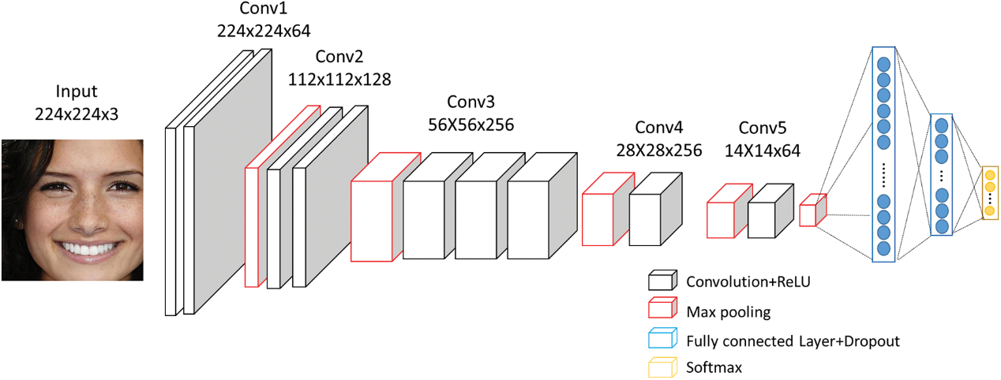

Figure 3.3. DCNN

**A. Convolutional Layer:** Convolutional layer performs the core building block of a Convolutional Network that does most of the computational heavy lifting. The primary purpose of Convolution layer is to extract features from the input data which is an image. Convolution preserves the spatial relationship between pixels by learning image features using small squares of input image. The input image is convoluted by employing a set of learnable neurons. This produces a feature map or activation map in the output image and after that the feature maps are fed as input data to the next convolutional layer.

**B. Pooling Layer:** Pooling layer reduces the dimensionality of each activation map but continues to have the most important information. The input images are divided into a set of non-overlapping rectangles. Each region is down-sampled by a non-linear operation such as average or maximum. This layer achieves better generalization, faster convergence, robust to translation and distortion and is usually placed between convolutional layers.

**C. ReLU Layer:** ReLU is a non-linear operation and includes units employing the rectifier. It is an element wise operation that means it is applied per pixel and reconstitutes all negative values in the feature map by zero. In order to understand how the ReLU operates, we assume that there is a neuron input given as x and from that the rectifier is defined as f(x)= max (0, x) in the literature for neural networks.

**D. Fully Connected Layer:** Fully Connected Layer (FCL) term refers to that every filter in the previous layer is connected to every filter in the next layer. The output from the convolutional, pooling, and ReLU layers are embodiments of high-level features of the input image. The goal of employing the FCL is to employ these features for classifying the input image into various classes based on the training dataset. FCL is regarded as final pooling layer feeding the features to a classifier that uses Softmax activation function. The sum of output probabilities from the Fully Connected Layer is 1. This is ensured by using the Softmax as the activation function. The Softmax function takes a vector of arbitrary real-valued scores and squashes it to a vector of values between zero and one that sum to one.

**3.4. Advantages**

* The system stores the faces that are detected and automatically marks vaccinated or not or Dose 1.
* Provide authorized access.
* Multiple face detection.
* Provide methods to maximize the number of extracted faces from an image.
* Ease of use.
* Manipulate and recognize the faces in real time using live video data.
* Multipurpose software.
* Can be used in different places.
* Vaccination Alert
* Vaccination Certificate with Face and QR

**CHAPTER 4**

**SYSTEM DESIGN**

**4.1. System Architecture**

Public Place

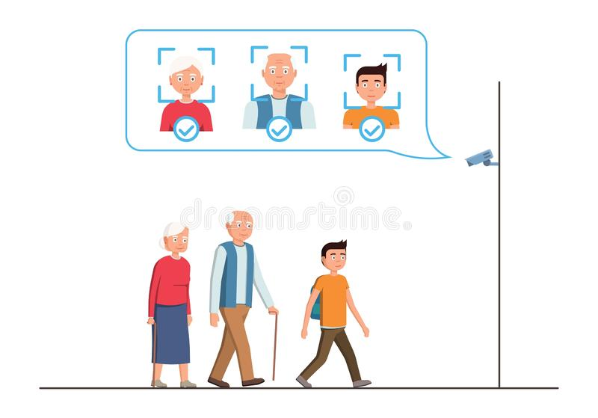

Aadhar Face Enrollment Center

Capture Face

Convert into Frames

Preprocessing

RNN Face Detection

Feature Extraction

CNN Classification



Aadhar Database

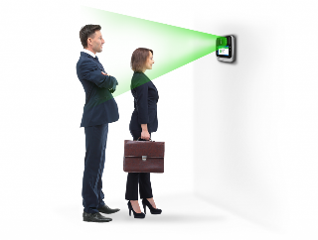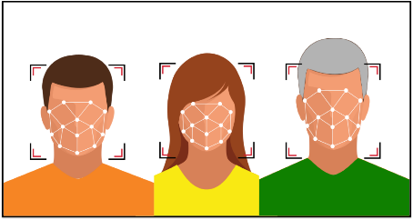

CCTV Capture Face

Prediction

Vaccinated or Non-Vaccinated

Allow or Not Allow

Verification Authority

Book Vacc.Apointment

Office

**4.2. System Flow**

Admin

Vaccinated

Non-Vaccinated

Face Frame acquisition

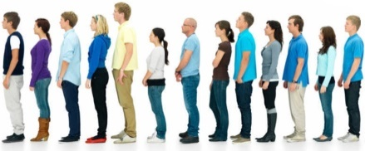

Aadhar Face Enrolment

Preprocessing

Face Detection

Face Recognition

Feature Extraction

Classification

Classified Result



Non – Vaccination Finder Module

Face Detection

Face Recognition

Feature Extraction

Prediction



Aadhar Database

Server

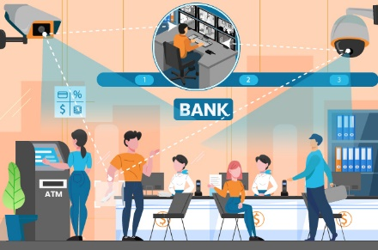

Frame Extraction

Alert

**4.3. Flow Chart**

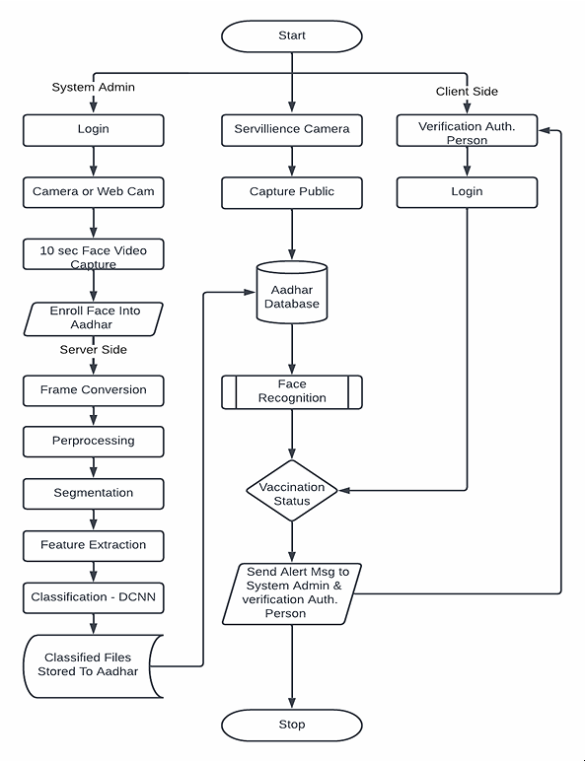

**CHAPTER 5**

**SYSTEM IMPLEMENTATION**

**5.1. Problem Description**

The COVID-19 vaccines are essential, lifesaving commodities in the current pandemic and ensuring equitable & indiscriminate access to the vaccines for all is of paramount importance. Millions of vulnerable people are at risk of missing out on COVID-19 vaccines as India uses its national digital identity for registration. However, deploying Aadhaar-based FRT for the verification process, deprives the citizens who do not possess or have not linked their Aadhaar cards to the CoWin portal or the on-site register, of the vital vaccines,” it said.

**5.2. Module Description**

1. **Covid 19 Vaccination Finder Web App**

Covid Vaccine Intelligence Network (Co-WIN), a portal set up to aid India’s Covid immunisation drive. In this portal an Aadhaar-based facial recognition system is developed to find Covid-19 vaccination finder across the country in order find to Non-Vaccinated Population. “Facial recognition authentication is used as one of the methods for Aadhaar Authentication for online verification of beneficiary prior to COVID-19 vaccination wherein facial template is captured and send to UIDAI for verification of image of beneficiary,”

**2. Face Recognition Module**

**2.1. Face Enrollment**

This module begins by registering a few frontal face of Bank Beneficiary templates. These templates then become the reference for evaluating and registering the templates for the other poses: tilting up/down, moving closer/further, and turning left/right.

**2.1.1. Face Image Acquisition**

Cameras should be deployed in ATM to capture relevant video. Computer and camera are interfaced and here webcam is used.

**2.1.1.1. Frame Extraction**

Frames are extracted from video input. The video must be divided into sequence of images which are further processed. The speed at which a video must be divided into images depends on the implementation of individuals. From we can say that, mostly 20-30 frames are taken per second which are sent to the next phases.

**2.1.2. Pre-processing**

Face Image pre-processing are the steps taken to format images before they are used by model training and inference. The steps to be taken are:

* Read image
* RGB to Grey Scale conversion
* Resize image

Original size (360, 480, 3) — (width, height, no. RGB channels)

Resized (220, 220, 3)

* Remove noise (Denoise)

smooth our image to remove unwanted noise. We do this using gaussian blur.

* Binarization

Image binarization is the process of taking a grayscale image and converting it to black-and-white, essentially reducing the information contained within the image from 256 shades of grey to 2: black and white, a binary image.

Face Image Dataset

Grey

Denoising

Binarization

Resize

**2.1.3. Face Detection**

Therefore, in this module, Region Proposal Network (RPN) generates RoIs by sliding windows on the feature map through anchors with different scales and different aspect ratios. Face detection and segmentation method based on improved RPN. RPN is used to generate RoIs, and RoI Align faithfully preserves the exact spatial locations. These are responsible for providing a predefined set of bounding boxes of different sizes and ratios that are going to be used for reference when first predicting object locations for the RPN.

Preprocessed Image

Background Subtraction

RPN

ROI

Foreground Subtraction

**Face Image segmentation using region growing (RG) method**

The region growing methodology and recent related work of region growing are described here.

RG is a simple image segmentation method based on the seeds of region. It is also classified as a pixel-based image segmentation method since it involves the selection of initial seed points. This approach to segmentation examines the neighbouring pixels of initial “seed points” and determines whether the pixel neighbours should be added to the region or not based on certain conditions. In a normal region growing technique, the neighbour pixels are examined by using only the “intensity” constraint. A threshold level for intensity value is set and those neighbour pixels that satisfy this threshold is selected for the region growing.

**RPN**

A **Region Proposal Network**, or **RPN**, is a fully convolutional network that simultaneously predicts object bounds and objectless scores at each position. The RPN is trained end-to-end to generate high-quality region proposals. It works on the feature map (output of CNN), and each feature (point) of this map is called Anchor Point. For each anchor point, we place 9 anchor boxes (the combinations of different sizes and ratios) over the image. These anchor boxes are cantered at the point in the image which is corresponding to the anchor point of the feature map.

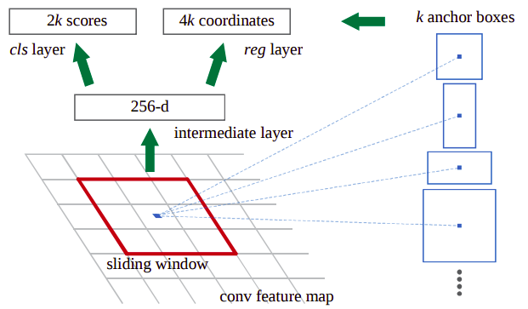

**Training of RPN.**

To know that for each location of the feature map we have 9 anchor boxes, so the total number is very big, but not all of them are relevant. If an anchor box having an object or part of the object within it then can refer it as a **foreground**, and if the anchor box doesn’t have an object within it then we can refer it as **background**.

So, for training, assign a label to each anchor box, based on its Intersection over Union (IoU) with given ground truth. We basically assign either of the three (1, -1, 0) labels to each anchor box.

Label = 1 (Foreground): An anchor can have label 1 in following conditions,

If the anchor has the highest IoU with ground truth.

If the IoU with ground truth is greater than 0.7. ( IoU >0.7).

Label = -1 (Background): An anchor is assigned with -1 if IoU < 0.3.

Label = 0: If it doesn’t fall under either of the above conditions, these types of anchors don’t contribute to the training, they are ignored.

After assigning the labels, it creates the mini-batch of 256 randomly picked anchor boxes, all of these anchor boxes are picked from the same image.

The ratio of the number of positive and negative anchor boxes should be 1:1 in the mini-batch, but if there are less than 128 positive anchor boxes then we pad the mini-batch with negative anchor boxes.

Now the RPN can be trained end-to-end by backpropagation and stochastic gradient descent (SGD).

The processing steps are

* Select the initial seed point
* Append the neighbouring pixels—intensity threshold
* Check threshold of the neighbouring pixel
* Thresholds satisfy-selected for growing the region.
* Process is iterated to end of all regions.

**2.1.4. Feature Extraction**

After the face detection, face image is given as input to the feature extraction module to find the key features that will be used for classification. With each pose, the facial information including eyes, nose and mouth is automatically extracted and is then used to calculate the effects of the variation using its relation to the frontal face templates.

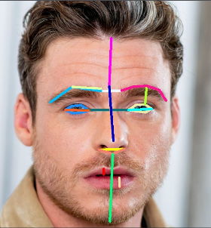

**Face Features**

* **Forehead Height:** distance between the top edge of eyebrows and the top edge of forehead.
* **Middle Face Height**: distance between the top edge of eyebrows and nose tip.
* **Lower Face Height**: distance between nose tip and the baseline of chin.
* **Jaw Shape**: A number to differentiate between jaw shapes. this number can be replaced if you use Face Shape Recognition, see (this) notebook.
* **Left Eye Area**
* **Right Eye Area**
* **Eye to Eye Distance**: distance between eyes (closest edges)
* **Eye to Eyebrow Distance**: distance between eye and eyebrow (left or right is determined by whice side of the face is more directed to the -screen-)
* **Eyebrows Distance:** horizontal distance between eyebrows
* **Eyebrow Shape Detector 1:** The angle between 3 points (eyebrow left edge, eyebrow center, eyebrow right edge), to differentiate between (Straight | non-straight) eyebrow shapes
* **Eyebrow Shape Detector 2:** A number to differentiate between (Curved | Angled) eyebrow shapes.
* **Eyebrow Slope**
* **Eye Slope Detector 1:** A method to calculate the slope of the eye. it's the slope of the line between eye's center point and eye's edge point. this detector is used to represent 3 types of eye slope (Upward, Downward, Straight).
* **Eye Slope Detector 2:** Another method to calculate the slope of the eye. it's the difference on Y-axis between eye's center point and eye's edge point. this detector isn't a 'mathematical' slope, but a number that can be clustered into 3 types of eye slope (Upward, Downward, Straight).
* **Nose Length**
* **Nose Width:** width of the lower part of the nose
* **Nose Arch:** Angle of the curve of the lower edge of the nose (longer nose = larger curve = smaller angle)
* **Upper Lip Height**
* **Lower Lip Height**

**Gray Level Co-occurrence Matrix**

GLCM is a second-order statistical texture analysis method. It examines the spatial relationship among pixels and defines how frequently a combination of pixels are present in an image in a given direction Θ and distance d. Each image is quantized into 16 gray levels (0–15) and 4 GLCMs (M) each for Θ = 0, 45, 90, and 135 degrees with d = 1 are obtained. From each GLCM, five features (Eq. 13.30–13.34) are extracted. Thus, there are 20 features for each image. Each feature is normalized to range between 0 to 1 before passing to the classifiers, and each classifier receives the same set of features.

The features we extracted can be grouped into three categories. The first category is the first order statistics, which includes maximum intensity, minimum intensity, mean, median, 10th percentile, 90th percentile, standard deviation, variance of intensity value, energy, entropy, and others. These features characterize the Gray level intensity of the tumour region.

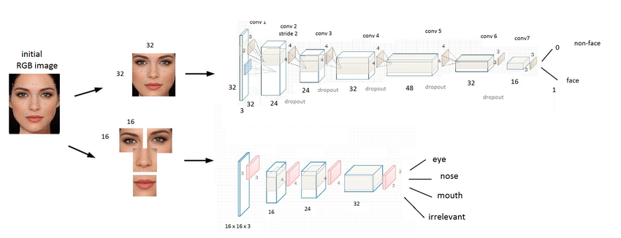

TABLE I. Formulas to calculate Texture Features from GLCM

|  |  |  |
| --- | --- | --- |
| Sl.No | **GLCM Feature** | **Formula** |
| 1. | *Contrast* | N–1  Σ Pi,j (i — j)2 i, j = 0 |
| 2. | *Correlation* | N–1 F(i — μ )(j — μ 1  Σ P I i j)  i,j I  i, j = 0 I √(σ2)(σ2) I  L i j ے |
| 3. | *Dissimilarity* | N–1  Σ Pi,j |i — j| i, j = 0 |
| 4. | *Energy* | N–1  Σ P2  i,j  i, j = 0 |
| 5. | *Entropy* | N–1  Σ Pi,j (— ln Pi,j) i, j = 0 |
| 6. | *Homogeneity* | N–1  Pi,j  Σ  1+ (i — j)2  i, j = 0 |
| 7. | *Mean* | N–1 N–1  μi = Σ i (Pi,j) , μj = Σ j (Pi,j) i, j = 0 i, j = 0 |
| 8. | *Variance* | N–1 N–1  σ2 = Σ Pi,j (i — μi )2 , σ2 = Σ Pi,j ( j — μj)2  i j  i, j = 0 i, j = 0 |
| 9. | *Standard Deviation* | σi = √σ2 , σj = √σ2  i j |

The second category is shape features, which include volume, surface area, surface area to volume ratio, maximum 3D diameter, maximum 2D diameter for axial, coronal and sagittal plane respectively, major axis length, minor axis length and least axis length, sphericity, elongation, and other features. These features characterize the shape of the tumour region.

The third category is texture features, which include 22 Gray level co-occurrence matrix (GLCM) features, 16 Gray level run length matrix (GLRLM) features, 16 Gray level size zone matrix (GLSZM) features, five neighbouring gray tone difference matrix (NGTDM) features and 14 Gray level dependence matrix (GLDM) Features. These features characterize the texture of the tumour region.

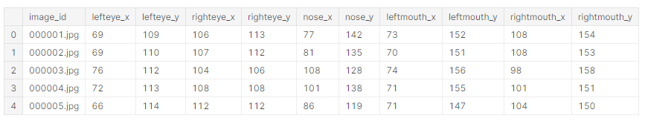

Facial Attribute

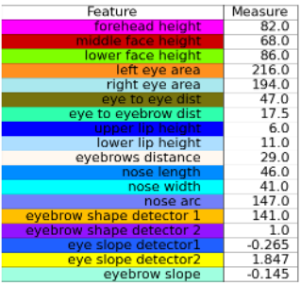

Facial Feature Measurement

Segmented Image

Shape

Color

Texture

Size

**2.1.5. Face Classification**

DCNN algorithms were created to automatically detect and reject improper face images during the enrolment process. This will ensure proper enrolment and therefore the best possible performance

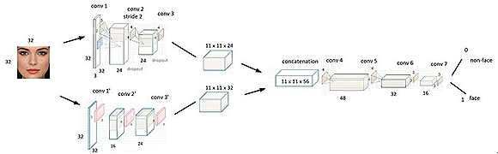

The CNN creates feature maps by summing up the convolved grid of a vector-valued input to the kernel with a bank of filters to a given layer. Then a non-linear rectified linear unit (ReLU) is used for computing the activations of the convolved feature maps. The new feature map obtained from the ReLU is normalized using local response normalization (LRN). The output from the normalization is further computed with the use of a spatial pooling strategy (maximum or average pooling). Then, the use of dropout regularization scheme is used to initialize some unused weights to zero and this activity most often takes place within the fully connected layers before the classification layer. Finally, the use of softmax activation function is used for classifying image labels within the fully connected layer.

**Fea.Extracted Data**

***CNN***

**Stastical**

**Storage**

**2.2. Face Identification**

After capturing the face image from the Camera, the image is given to face detection module. This module detects the image regions which are likely to be human. After the face detection using Region Proposal Network (RPN), face image is given as input to the feature extraction module to find the key features that will be used for classification. The module composes a very short feature vector that is well enough to represent the face image. Here, it is done with DCNN with the help of a pattern classifier, the extracted features of face image are compared with the ones stored in the face database. The face image is then classified as either known or unknown. If the image face is known, then the covid vaccination details of the particular person is displayed.

**3. Prediction**

In this module the matching process is done with trained classified result and test Live Camera Captured Classified file. Hamming Distance is used to calculate the difference according to the result the prediction accuracy will be displayed.

**Trained Data File**

***Distance Metrics***

**Stastical**

**Test Data**

**Result visualization**

**Stastical**

**4. Non-Vaccination Finder**

This module is capable of identifying or verifying a non-Vaccination person by comparing and analysing patterns, shapes and proportions of their facial features and contours from the trained classified file. When a facial image (probe image) is entered into the system it is automatically encoded by an algorithm and compared to the profiles already stored in the Aadhar database system.

**5. Notification**

This information is then passed on to the countries that provided the images, and to those that would be concerned by the profile or a match. The results are returned quickly to enable immediate follow-up action.

**6. Performance Analysis**

The important points involved with the performance metrics are discussed based on the context of this project:

True Positive (TP): There is a Face, and the algorithms detect Card Holder.

False Positive (FP): There is no Face, but the algorithms detect as Card Holder and display Card Holder name.

False Negative (FN): There is a Face, but the algorithms do not detect Card Holder and name.

True Negative (TN): There is no Face, and nothing is being detected.

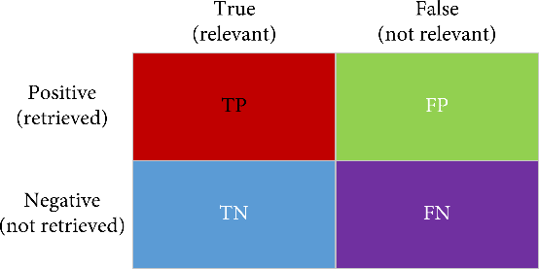

Fig. 8.1. Parameter Definition

* **Accuracy**

Accuracy is a measure that tells whether a model/algorithm is being trained correctly and how it performs. In the context of this thesis, accuracy tells how well it is performing in detecting Face in ATM Machine. Accuracy is calculated using the following formula.

Accuracy = (T P + T N)/ (T P + T N + F P + F N)

Accuracy: 0.9984025559105432

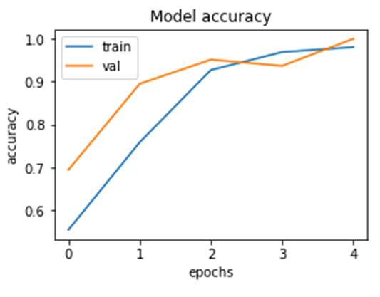

* **Precision**

It denotes the ratio of positively predicted cases that are actually positive. In the context of this thesis, precision measures the fraction of objects that are predicted to be Card Holder and are actually Card Holder Face present in ATM environment. Precision is calculated using the following formula.

Precision = T P/ (T P + F P)

Precision: 0.9990234375

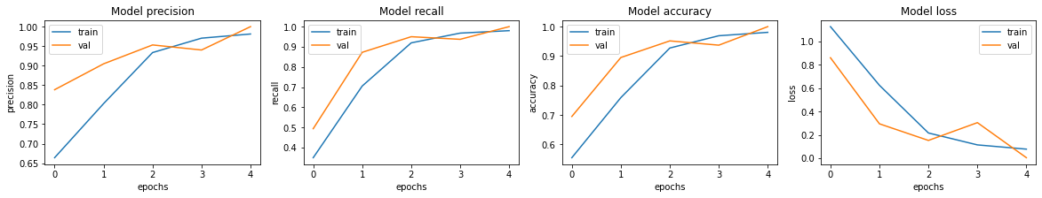

* **Recall**

It is the ratio between actual positive cases that are predicted to be positive. In the context of this thesis, recall measures the fraction of Face that are predicted as Face and identify the card Holder. Recall is calculated using the following formula.Recall =T P/ (T P + F N)

Recall: 0.9964285714285714

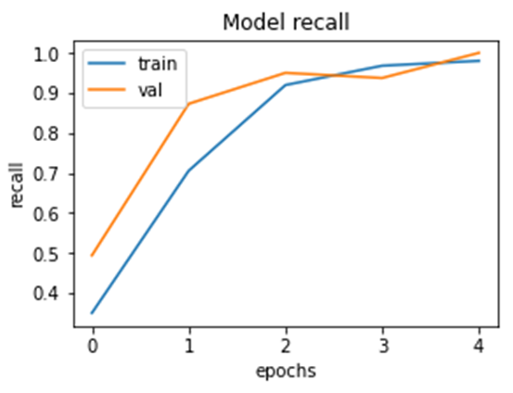

* **F1 Score**

It is also known as balanced F-score or F-measure. F1 score is a measure of accuracy of a model combining precision and recall. In the context of this thesis, a good F1 score shows that there are less false positives and false negatives. This shows that the model is correctly identifying Face in ATM environment.

A model/algorithm is considered perfect if F1 score is 1. It is calculated using the following formula.

F1 = 2 × (Precision × Recall /Precision + Recall)

F1_score: 0.9977122020583142

**Training time**

Training time is metric used in this thesis to measure the time taken to train the selected machine learning algorithms on the dataset.

**Prediction Speed**

Speed is a metric used in this thesis to measure the time taken for the algorithms to process and detect obstacle.

**Loss Function**

Loss function, to perform feature matching between the ground truth and the output of segmentation network, optimizing also the network weights on features extracted at multiple resolutions rather than focusing just on the pixel level.



**5.3. DCNN Overview**

Deep learning is a machine learning technique used to build artificial intelligence (AI) systems. It is based on the idea of ​​artificial neural networks (ANN), designed to perform complex analysis of large amounts of data by passing it through multiple layers of neurons. There is a wide variety of deep neural networks (DNN). Deep convolutional neural networks (CNN or DCNN) are the type most commonly used to identify patterns in images and video. DCNNs have evolved from traditional artificial neural networks, using a three-dimensional neural pattern inspired by the visual cortex of animals.

Deep convolutional neural networks are mainly focused on applications like object detection, image classification, recommendation systems, and are also sometimes used for natural language processing. Deep Convolutional Neural Networks (DCNN) is a Deep Learning (DL) Method which is different from normal Convolutional Neural Network (CNN) in terms of number of hidden layers usually more than 5 which are used to extract more features and increase the accuracy of the prediction. There are two kinds of DCNN, one is increasing the number of hidden layers or by increasing the number of nodes in the hidden layer. The DCNN method that has been widely and successfully applied to computer vision tasks including object localization, detection, and image classification is a supervised learning task that uses the raw data to determine the classification features, in contrast to other machine learning (ML) techniques that require pre-selection of the input features (or attributes). The strength of DCNNs is in their layering. A DCNN uses a three-dimensional neural network to process the red, green, and blue elements of the image at the same time. This considerably reduces the number of artificial neurons required to process an image, compared to traditional feed forward neural networks. Deep convolutional neural networks receive images as an input and use them to train a classifier. The network employs a special mathematical operation called a “convolution” instead of matrix multiplication.

**5.3.1. Algorithms**

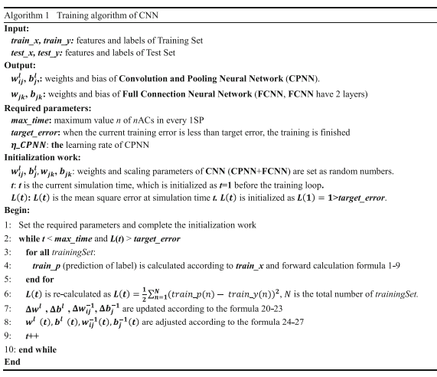

**5.4. ALGORITHM DESCRIPTION**

**Working of Facial Recognition**

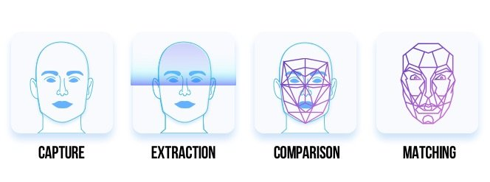

1. **Concept of feature vector**: Every Machine Learning algorithm takes a dataset as input and learns from this data. The algorithm goes through the data and identifies patterns in the data. The challenging part is to convert a particular face into numbers – Machine Learning algorithms only understand numbers.
2. This numerical representation of a “face” (or an element in the training set) is termed as a feature vector. A feature vector comprises of various numbers in a specific order.
3. You can take various attributes to define a face like:
   * Height/width of face (cm)
   * Color of face (R,G,B)
   * Height/width of parts of face like nose & lips (cm)
   * We can consider the ratios as feature vector after rescaling
4. A feature vector can be created by organising these attributes to into a table, say, for a certain set of values of attributes your table may look like this:

| **Height of face (cm)** | **Width of face (cm)** | **Average color of face (R, G, B)** | **Width of lips (cm)** | **Height of nose(cm)** |
| --- | --- | --- | --- | --- |
| 23.1 | 15.8 | (255, 224, 189) | 5.2 | 4.4 |

image now becomes a vector that could be represented as [23.1, 15.8, 255, 224, 189, 5.2, 4.4]. Now can add a number of other features like hair color & spectacles. Keep in mind that a simple model gives the best result. Adding a greater number of features may not give accurate results (See overfitting and underfitting).

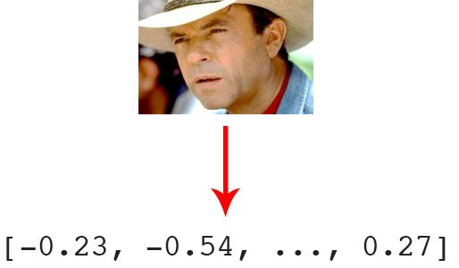

Machine learning helps you with two main things:

* **Deriving the feature vector**: As it is a difficult process to involve all features by name, we convert it to feature vector. This is then used by the algorithm. A Machine Learning algorithm can intelligently label out many of such features.
* **Matching algorithms**: Once the feature vectors have been obtained, a Machine Learning algorithm needs to match a new image with the set of feature vectors present in the corpus.

**5.5. DCNN Basic Architecture**

There are two main parts to a CNN architecture

A **convolution tool** that separates and identifies the various features of the image for analysis in a process called as Feature Extraction

A **fully connected layer** that utilizes the output from the convolution process and predicts the class of the image based on the features extracted in previous stages.

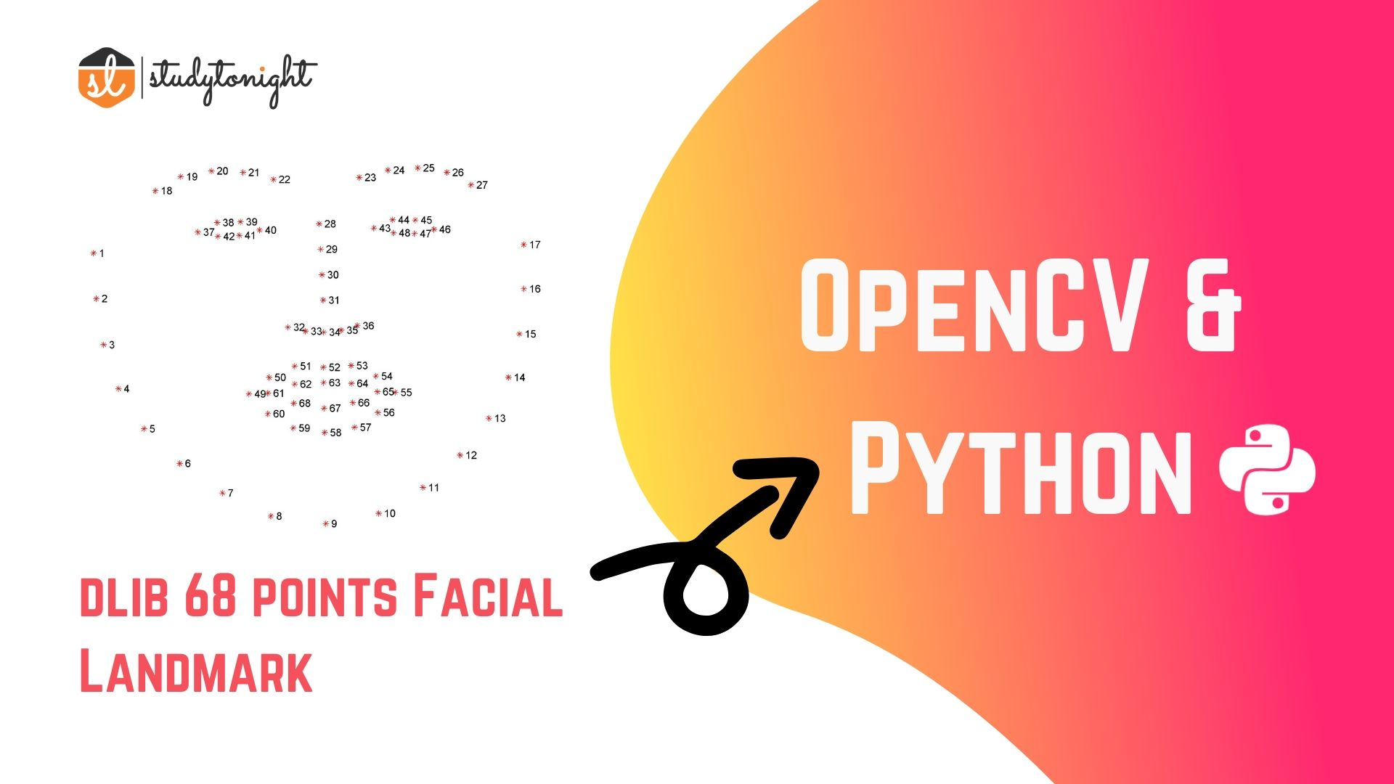

Face Landmark Points

There are mostly two steps to detect face landmarks in an image which are given below:

* **Face detection:** Face detection is the first methods which locate a human face and return a value in x,y,w,h which is a rectangle.
* **Face landmark:** After getting the location of a face in an image, then we have to through points inside of that rectangle.

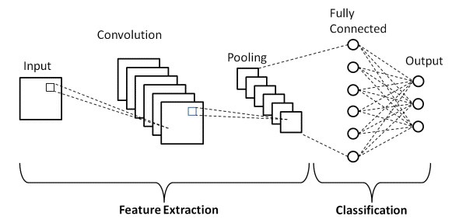

CNN

**Convolution Layers**

There are three types of layers that make up the CNN which are the convolutional layers, pooling layers, and fully-connected (FC) layers. When these layers are stacked, a CNN architecture will be formed. In addition to these three layers, there are two more important parameters which are the dropout layer and the activation function which are defined below.

**1. Convolutional Layer**

This layer is the first layer that is used to extract the various features from the input images. In this layer, the mathematical operation of convolution is performed between the input image and a filter of a particular size MxM. By sliding the filter over the input image, the dot product is taken between the filter and the parts of the input image with respect to the size of the filter (MxM).

The output is termed as the Feature map which gives us information about the image such as the corners and edges. Later, this feature map is fed to other layers to learn several other features of the input image.

**2. Pooling Layer**

In most cases, a Convolutional Layer is followed by a Pooling Layer. The primary aim of this layer is to decrease the size of the convolved feature map to reduce the computational costs. This is performed by decreasing the connections between layers and independently operates on each feature map. Depending upon method used, there are several types of Pooling operations.

In Max Pooling, the largest element is taken from feature map. Average Pooling calculates the average of the elements in a predefined sized Image section. The total sum of the elements in the predefined section is computed in Sum Pooling. The Pooling Layer usually serves as a bridge between the Convolutional Layer and the FC Layer

**3. Fully Connected Layer**

The Fully Connected (FC) layer consists of the weights and biases along with the neurons and is used to connect the neurons between two different layers. These layers are usually placed before the output layer and form the last few layers of a CNN Architecture. In this, the input image from the previous layers is flattened and fed to the FC layer. The flattened vector then undergoes few more FC layers where the mathematical functions operations usually take place. In this stage, the classification process begins to take place.

**4. Dropout**

Usually, when all the features are connected to the FC layer, it can cause overfitting in the training dataset. Overfitting occurs when a particular model works so well on the training data causing a negative impact in the model’s performance when used on a new data. To overcome this problem, a dropout layer is utilized wherein a few neurons are dropped from the neural network during training process resulting in reduced size of the model. On passing a dropout of 0.3, 30% of the nodes are dropped out randomly from the neural network.

**5. Activation Functions**

Finally, one of the most important parameters of the CNN model is the activation function. They are used to learn and approximate any kind of continuous and complex relationship between variables of the network. In simple words, it decides which information of the model should fire in the forward direction and which ones should not at the end of the network. It adds non-linearity to the network. There are several commonly used activation functions such as the ReLU, SoftMax, tanH and the Sigmoid functions. Each of these functions have a specific usage. For a binary classification DCNN model, sigmoid and SoftMax functions are preferred a for a multi-class classification, generally SoftMax us used.

**CHAPTER 6**

**DATA FLOW DIAGRAM**

**6.1. Level 0**

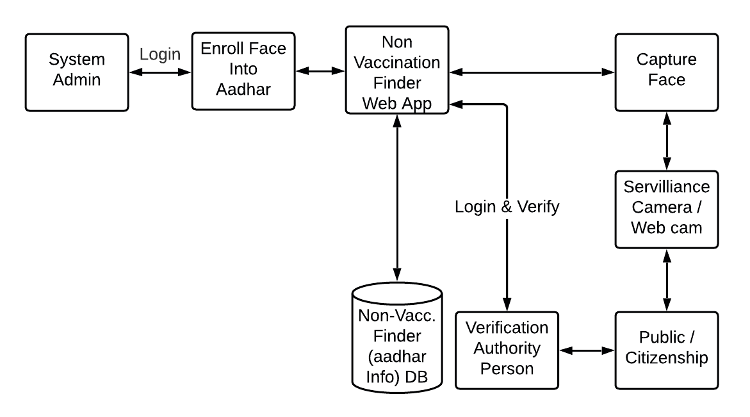

**6.2. Level 1**

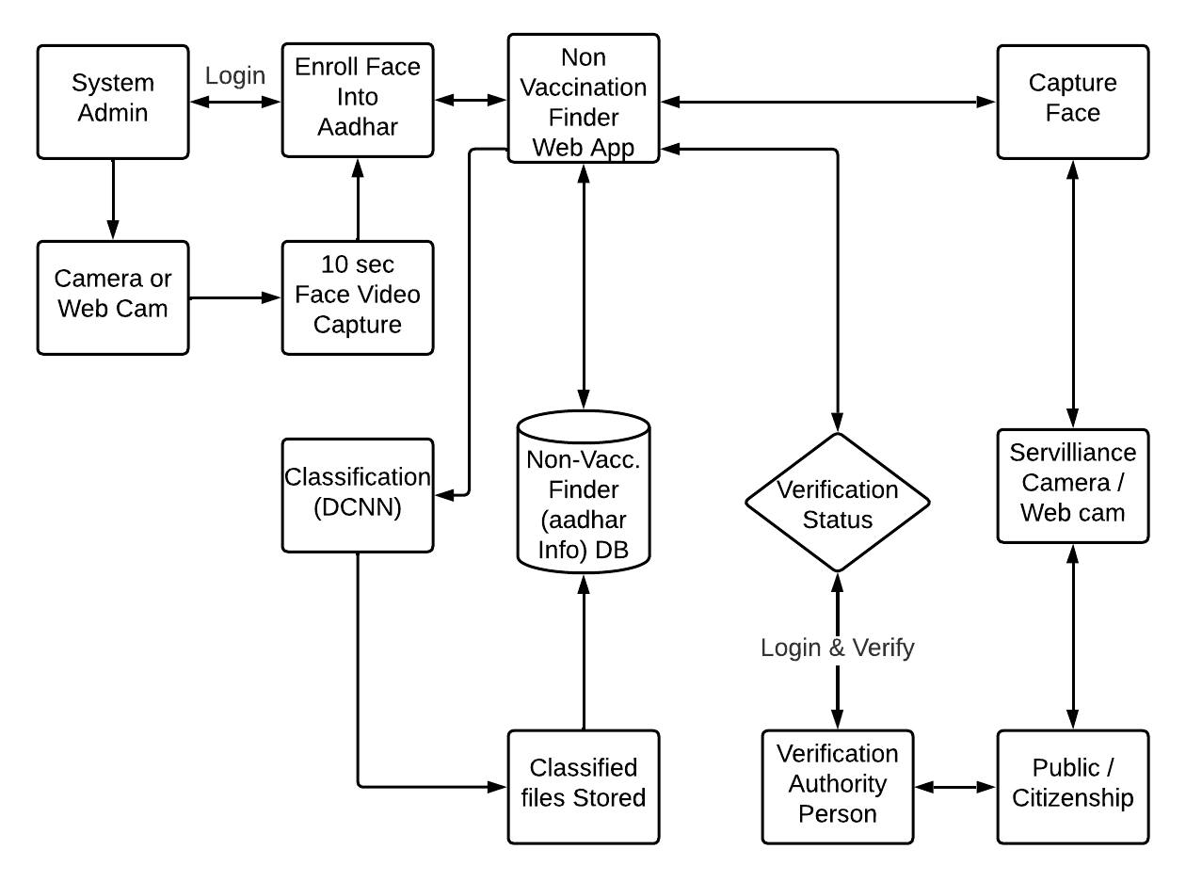

**6.3. Level 2**

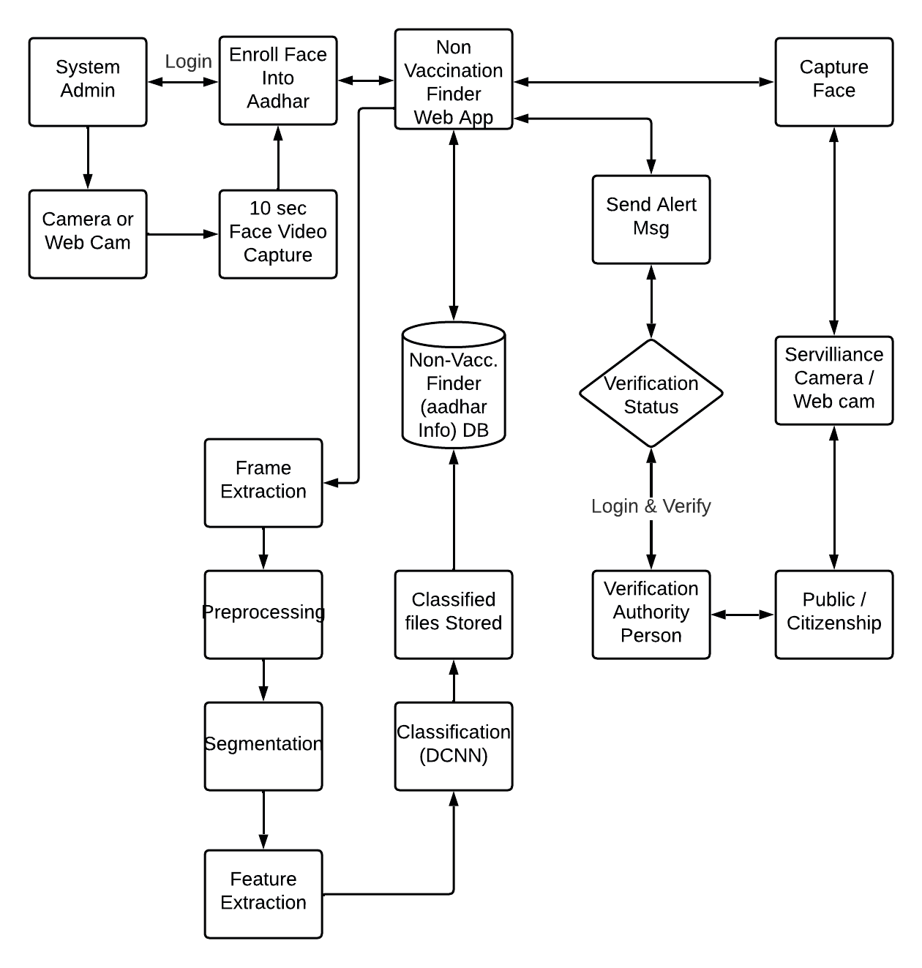

**CHAPTER 7**

**UML DIAGRAMS**

**7.1. Use Case**

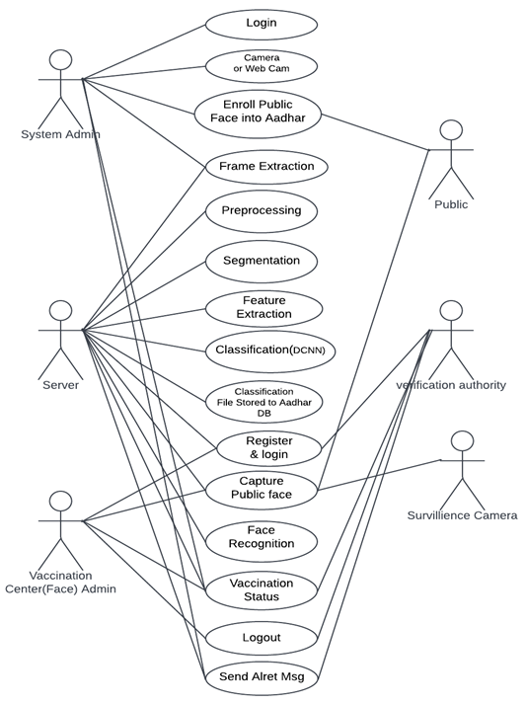

**7.2. Class Diagram**

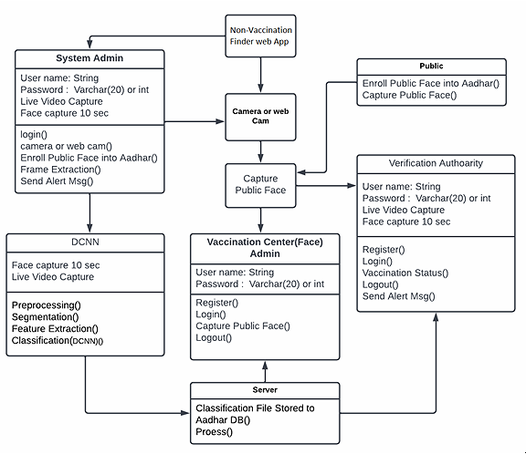

**7.3. Sequence Diagram**

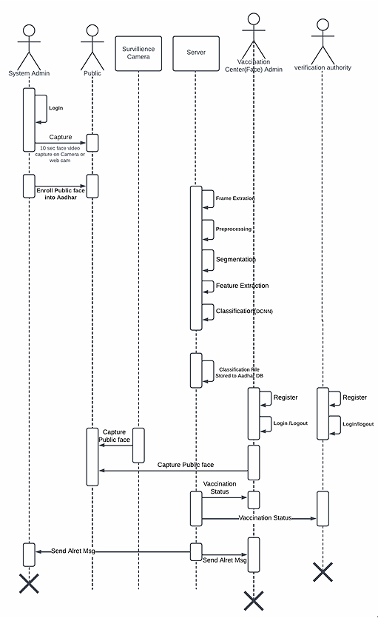

**7.4. Collaboration Diagram**

**7.5. Activity Diagram**

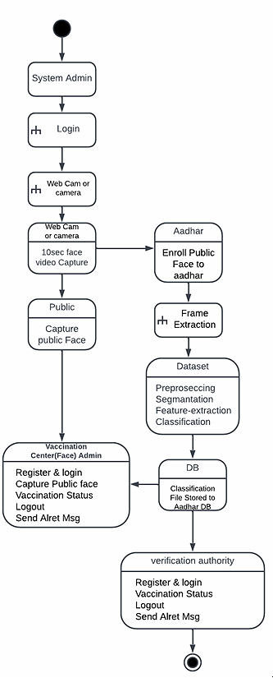

**7.6. Component Diagram**

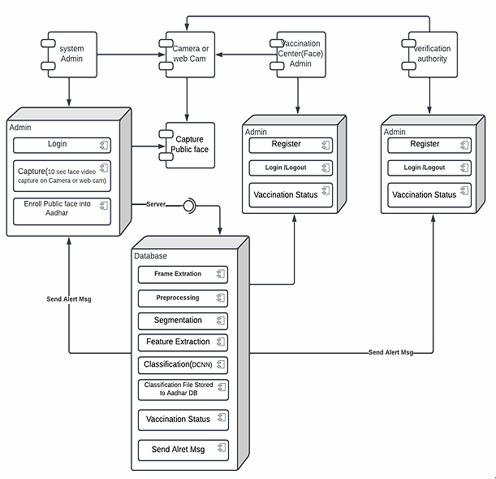

**7.7. Deployment Diagram**

**7.8. HIPO Diagram**

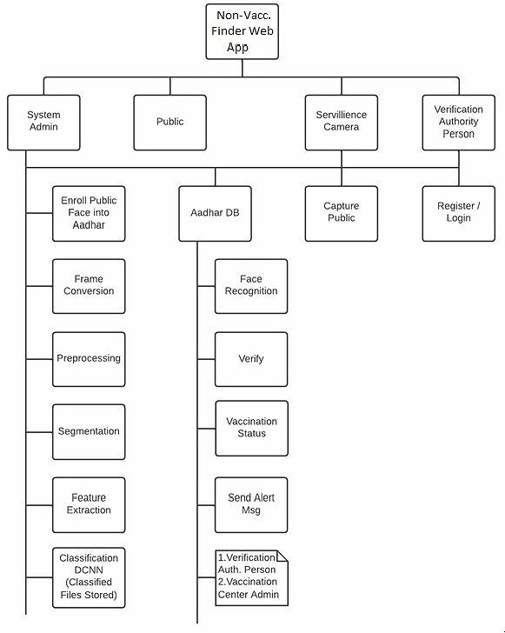

**7.9. IPO Diagram**

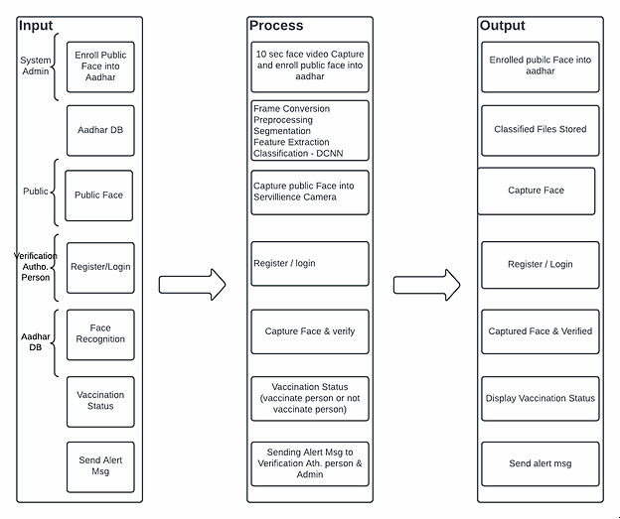

**7.10. ER-Diagram**

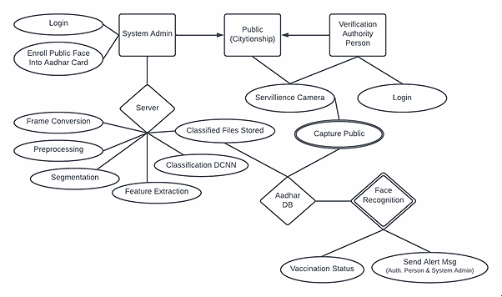

**CHAPTER 8**

**SYSTEM SPECIFICATION**

**8.1 Hardware specification**

* Processors: Intel® Core™ i5 processor 4300M at 2.60 GHz or 2.59 GHz (1 socket, 2 cores, 2 threads per core), 8 GB of DRAM
* Disk space: 320 GB
* Operating systems: Windows® 10, macOS*, and Linux*
* Web Camera

**8.2 Software specification**

* Server Side : Python 3.7.4(64-bit) or (32-bit)
* Client Side : HTML, CSS, Bootstrap
* IDE : Flask 1.1.1
* Back end : MySQL 5.
* Server : Wampserver 2i
* OS : Windows 10 64 –bit or Ubuntu 18.04 LTS “Bionic Beaver”

**CHAPTER 9**

**SOFTWARE DESCRIPTION**

**9.1. Python 3.7.4**

Python is a general-purpose interpreted, interactive, object-oriented, and high-level programming language. It was created by Guido van Rossum during 1985- 1990. Like Perl, Python source code is also available under the GNU General Public License (GPL). This tutorial gives enough understanding on Python programming language.



Python is a high-level, interpreted, interactive and object-oriented scripting language. Python is designed to be highly readable. It uses English keywords frequently where as other languages use punctuation, and it has fewer syntactical constructions than other languages. Python is a MUST for students and working professionals to become a great Software Engineer specially when they are working in Web Development Domain.

Python is currently the most widely used multi-purpose, high-level programming language. Python allows programming in Object-Oriented and Procedural paradigms. Python programs generally are smaller than other programming languages like Java. Programmers have to type relatively less and indentation requirement of the language, makes them readable all the time. Python language is being used by almost all tech-giant companies like – Google, Amazon, Facebook, Instagram, Dropbox, Uber… etc. The biggest strength of Python is huge collection of standard libraries which can be used for the following:

* Machine Learning
* GUI Applications (like Kivy, Tkinter, PyQt etc.)
* Web frameworks like Django (used by YouTube, Instagram, Dropbox)
* Image processing (like OpenCV, Pillow)
* Web scraping (like Scrapy, BeautifulSoup, Selenium)
* Test frameworks
* Multimedia
* Scientific computing
* Text processing and many more.

**9.1.1. Tensor Flow**

TensorFlow is an end-to-end open-source platform for machine learning. It has a comprehensive, flexible ecosystem of tools, libraries, and community resources that lets researchers push the state-of-the-art in ML, and gives developers the ability to easily build and deploy ML-powered applications.



TensorFlow provides a collection of workflows with intuitive, high-level APIs for both beginners and experts to create machine learning models in numerous languages. Developers have the option to deploy models on a number of platforms such as on servers, in the cloud, on mobile and edge devices, in browsers, and on many other JavaScript platforms. This enables developers to go from model building and training to deployment much more easily.

**9.1.2. Keras**

Keras is a deep learning API written in Python, running on top of the machine learning platform TensorFlow. It was developed with a focus on enabling fast experimentation.



* Allows the same code to run on CPU or on GPU, seamlessly.
* User-friendly API which makes it easy to quickly prototype deep learning models.
* Built-in support for convolutional networks (for computer vision), recurrent networks (for sequence processing), and any combination of both.
* Supports arbitrary network architectures: multi-input or multi-output models, layer sharing, model sharing, etc. This means that Keras is appropriate for building essentially any deep learning model, from a memory network to a neural Turing machine.

**9.1.3. Pandas**

pandas is a fast, powerful, flexible and easy to use open source data analysis and manipulation tool, built on top of the Python programming language. pandas is a Python package that provides fast, flexible, and expressive data structures designed to make working with "relational" or "labeled" data both easy and intuitive. It aims to be the fundamental high-level building block for doing practical, real world data analysis in Python.



Pandas is mainly used for data analysis and associated manipulation of tabular data in Data frames. Pandas allows importing data from various file formats such as comma-separated values, JSON, Parquet, SQL database tables or queries, and Microsoft Excel. Pandas allows various data manipulation operations such as merging, reshaping, selecting, as well as data cleaning, and data wrangling features. The development of pandas introduced into Python many comparable features of working with Data frames that were established in the R programming language. The panda’s library is built upon another library NumPy, which is oriented to efficiently working with arrays instead of the features of working on Data frames.

**9.1.4. NumPy**

NumPy, which stands for Numerical Python, is a library consisting of multidimensional array objects and a collection of routines for processing those arrays. Using NumPy, mathematical and logical operations on arrays can be performed.



NumPy is a general-purpose array-processing package. It provides a high-performance multidimensional array object, and tools for working with these arrays.

**9.1.5. Matplotlib**

Matplotlib is a comprehensive library for creating static, animated, and interactive visualizations in Python. Matplotlib makes easy things easy and hard things possible.



Matplotlib is a plotting library for the Python programming language and its numerical mathematics extension NumPy. It provides an object-oriented API for embedding plots into applications using general-purpose GUI toolkits like Tkinter, wxPython, Qt, or GTK.

**9.1.6. Scikit Learn**

scikit-learn is a Python module for machine learning built on top of SciPy and is distributed under the 3-Clause BSD license.



Scikit-learn (formerly scikits.learn and also known as sklearn) is a free software machine learning library for the Python programming language.It features various classification, regression and clustering algorithms including support-vector machines, random forests, gradient boosting, k-means and DBSCAN, and is designed to interoperate with the Python numerical and scientific libraries NumPy and SciPy.

**9.1.7. Pillow**

Pillow is the friendly PIL fork by Alex Clark and Contributors. PIL is the Python Imaging Library by Fredrik Lundh and Contributors.



Python pillow library is used to image class within it to show the image. The image modules that belong to the pillow package have a few inbuilt functions such as load images or create new images, etc.

**9.1.8. OpenCV**

OpenCV is an open-source library for the computer vision. It provides the facility to the machine to recognize the faces or objects.



In OpenCV, the CV is an abbreviation form of a computer vision, which is defined as a field of study that helps computers to understand the content of the digital images such as photographs and videos.

**9.2. MySQL**

MySQL tutorial provides basic and advanced concepts of MySQL. Our MySQL tutorial is designed for beginners and professionals. MySQL is a relational database management system based on the Structured Query Language, which is the popular language for accessing and managing the records in the database. MySQL is open-source and free software under the GNU license. It is supported by Oracle Company. MySQL database that provides for how to manage database and to manipulate data with the help of various SQL queries. These queries are: insert records, update records, delete records, select records, create tables, drop tables, etc. There are also given MySQL interview questions to help you better understand the MySQL database.



MySQL is currently the most popular database management system software used for managing the relational database. It is open-source database software, which is supported by Oracle Company. It is fast, scalable, and easy to use database management system in comparison with Microsoft SQL Server and Oracle Database. It is commonly used in conjunction with PHP scripts for creating powerful and dynamic server-side or web-based enterprise applications. It is developed, marketed, and supported by MySQL AB, a Swedish company, and written in C programming language and C++ programming language. The official pronunciation of MySQL is not the My Sequel; it is My Ess Que Ell. However, you can pronounce it in your way. Many small and big companies use MySQL. MySQL supports many Operating Systems like Windows, Linux, MacOS, etc. with C, C++, and Java languages.

**9.3. WampServer**

WampServer is a Windows web development environment. It allows you to create web applications with Apache2, PHP and a MySQL database. Alongside, PhpMyAdmin allows you to manage easily your database.



WAMPServer is a reliable web development software program that lets you create web apps with MYSQL database and PHP Apache2. With an intuitive interface, the application features numerous functionalities and makes it the preferred choice of developers from around the world. The software is free to use and doesn’t require a payment or subscription.

**9.4. Bootstrap 4**

Bootstrap is a free and open-source tool collection for creating responsive websites and web applications. It is the most popular HTML, CSS, and JavaScript framework for developing responsive, mobile-first websites.



It solves many problems which we had once, one of which is the cross-browser compatibility issue. Nowadays, the websites are perfect for all the browsers (IE, Firefox, and Chrome) and for all sizes of screens (Desktop, Tablets, Phablets, and Phones). All thanks to Bootstrap developers -Mark Otto and Jacob Thornton of Twitter, though it was later declared to be an open-source project.

**Easy to use**: Anybody with just basic knowledge of HTML and CSS can start using Bootstrap

**Responsive features**: Bootstrap's responsive CSS adjusts to phones, tablets, and desktops

**Mobile-first approach**: In Bootstrap, mobile-first styles are part of the core framework

**Browser compatibility**: Bootstrap 4 is compatible with all modern browsers (Chrome, Firefox, Internet Explorer 10+, Edge, Safari, and Opera)

**9.5. Flask**

[Flask](http://flask.pocoo.org/) is a web framework. This means flask provides you with tools, libraries and technologies that allow you to build a web application. This web application can be some web pages, a blog, a wiki or go as big as a web-based calendar application or a commercial website.



Flask is often referred to as a micro framework. It aims to keep the core of an application simple yet extensible. Flask does not have built-in abstraction layer for database handling, nor does it have formed a validation support. Instead, Flask supports the extensions to add such functionality to the application.  Although Flask is rather young compared to most [Python](https://quintagroup.com/services/python) frameworks, it holds a great promise and has already gained popularity among Python web developers. Let’s take a closer look into Flask, so-called “micro” framework for Python.

Flask was designed to be easy to use and extend. The idea behind Flask is to build a solid foundation for web applications of different complexity. From then on you are free to plug in any extensions you think you need. Also, you are free to build your own modules. Flask is great for all kinds of projects. It's especially good for prototyping.

Flask is part of the categories of the micro-framework. Micro-framework is normally framework with little to no dependencies to external libraries. This has pros and cons. Pros would be that the framework is light, there are little dependency to update and watch for security bugs, cons is that some time you will have to do more work by yourself or increase yourself the list of dependencies by adding plugins. In the case of Flask, its dependencies are:

**WSGI-**Web Server Gateway Interface (WSGI) has been adopted as a standard for Python web application development. WSGI is a specification for a universal interface between the web server and the web applications.

**Werkzeug-**It is a WSGI toolkit, which implements requests, response objects, and other utility functions. This enables building a web framework on top of it. The Flask framework uses Werkzeug as one of its bases.

**Jinja2** Jinja2 is a popular templating engine for Python. A web templating system combines a template with a certain data source to render dynamic web pages.

**CHAPTER 10**

**HARDWARE DESCRIPTION**

**10.1. Web Camera**

(WEB CAMera) A video camera that faces the user. Webcams are built into laptops but are separate units that attach to the monitor of a desktop computer. A Webcam is used for video calling and taking selfies, and although most models include a microphone, many users opt to use headphones for better audio quality. Stand-alone microphones with greater sensitivity are also used for studio presentations.

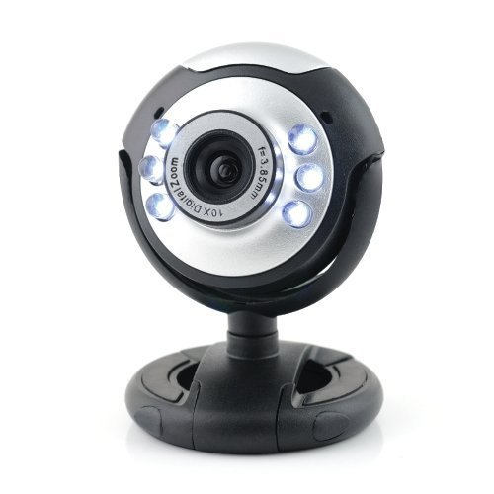

Webcams come with software that needs to be installed on the computer to help users record video on or stream it from the Web. Webcams are capable of taking pictures as well as high-definition videos, although the video quality can be lower compared to other camera models.

**CHAPTER 11**

**Result and Discussion**

A comparative evaluation based on the accuracy of the proposed face recognition Deep Convolutional Neural Network (DCNN) system, compared to Support Vector Machine (SVM), Linear Discriminant Analysis (LDA), Principal Component Analysis (PCA), as statistical approach, Multi-Layer Perceptron (MLP), Combined Radial Basis Function (CRBF), as neural network approach, Deep Restricted Boltzmann Machine (DRBM), Deep Belief Neural Nets (DBNN).The results show that the proposed DCNN achieves higher accuracy compared to other approaches.

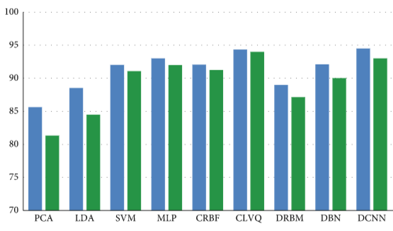

Face Recognition Accuracy

**CHAPTER 12**

**12.1. Conclusion**

A facial recognition system is a technology capable of matching a human face from a digital image or a video frame against a database of faces, typically employed to authenticate users through ID verification services, works by pinpointing and measuring facial features from a given image. In the context of the coronavirus disease (COVID-19) pandemic, A face recognition-based person’s current vaccination status to protect against COVID-19 can then be used for continuity of care or as proof of vaccination for purposes other than health care. Facial recognition technology (FRT) along with the Aadhaar to authenticate people before entering into any kinds of service. This project provides COVID-19 vaccination status using their face and attest that an individual has received a vaccine or not and alert them to get vaccinated. The proposed classifier performance evaluation was presented as a confusion matrix, in terms of sensitivity, specificity, precision, accuracy, and F1score. Results indicated that the proposed classifier has achieved higher recognition accuracy than ten other classifiers of the state of art.

**12.2 Future Enhancement**

For the future, we will proceed to enhance the proposed classifier performance to be able to handle the spoof attacks problem that may be occurred by fake subjects. Also, we can apply this technique to vote anywhere in India.

**References**

1. P. Dou and I. A. Kakadiaris, “Multi-view 3D face reconstruction with deep recurrent neural networks,” Image and Vision Computing, vol. 80, pp. 80–91, 2018.
2. X. Shao, J. Lyu, J. Xing et al., “3D faces shape regression from 2D videos with multi-reconstruction and mesh retrieval,” in Proceedings of the IEEE International Conference on Computer Vision Workshops, Seoul, Republic of Korea, October 2019.
3. F. Wu, L. Bao, Y. Chen et al., “MVF-Net: Multi-view 3d face morphable model regression,” in Proceedings of the IEEE Conference on Computer Vision and Pattern Recognition, pp. 959–968, Long beach, CA, USA, June 2019.
4. H. Zhou, P. Chen, and W. Shen, “A multi-view face recognition system based on cascade face detector and improved Dlib,” in MIPPR 2017: Pattern Recognition and Computer Vision, Xiangyang, China, March 2018.
5. B. Renuka, B. Sivaranjani, A. M. Lakshmi, and D. N. Muthukumaran, “Automatic enemy detecting defense robot by using face detection technique’,” Asian Journal of Applied Science and Technology, vol. 2, no. 2, pp. 495–501, 2018.
6. X. Sun, P. Wu, and S. C. H. Hoi, “Face detection using deep learning: An improved faster RCNN approach,” Neurocomputing, vol. 299, pp. 42–50, 2018.
7. E. Zhou, Z. Cao, and J. Sun, “Gridface: Face rectification via learning local homography transformations,” in Proceedings of the European Conference on Computer Vision (ECCV), pp. 3–20, Munich, Germany, September 2018.
8. K. Zhang, Z. Zhang, Z. Li, and Y. Qiao, “Joint face detection and alignment using multitask cascaded convolutional networks,” IEEE Signal Processing Letters, vol. 23, no. 10, pp. 1499–1503, 2016.
9. T. Zhang, W. Zheng, Z. Cui, Y. Zong, J. Yan, and K. Yan, “A deep neural network-driven feature learning method for multi-view facial expression recognition,” IEEE Transactions on Multimedia, vol. 18, no. 12, pp. 2528–2536, 2016.
10. S. S. Farfade, M. J. Saberian, and L.-J. Li, “Multi-view face detection using deep convolutional neural networks,” in Proceedings of the 5th ACM on International Conference on Multimedia Retrieval, pp. 643–650, Shanghai, China, June 2015.